**Sentinel-2 Agriculture**

Design Justification File

Benchmarking for L4 dynamic crop mask product



|  |  |
| --- | --- |
| Milestone | Milestone 2 |
| Version | 1.0 |
| Authors | CESBIO - Silvia Valero, David Morin  UCL - Guadalupe Sepulcre, Nicolas Matton |

***This page is intentionally blank***

***Table of contents***

1 Review of the state of the art literature 10

2 Selection of the benchmarked algorithms 13

2.1 Supervised approach 13

2.1.1 Features characterizing crops used in a supervised dynamic system 14

2.1.2 The choice of the supervised classifier used in a supervised dynamic system 15

2.2 Unsupervised approach 15

2.2.1 Features selection 16

2.2.2 Use of simple rules 17

2.2.3 Use of thresholds 18

2.2.4 Classical unsupervised approach 19

2.2.5 Trimming approach 20

2.3 Filtering, smoothing and selecting the spatial unit 21

2.4 Algorithms to benchmark 21

3 Criteria for benchmark analysis 23

4 Benchmark results 24

4.1 Evaluating the object-level image representation 24

4.2 Comparison between supervised and unsupervised approaches 25

4.2.1 Belgium 27

4.2.2 Argentina 28

4.2.3 China 29

4.2.4 Ukraine 32

4.2.5 South Africa 33

4.2.6 France 34

4.2.7 Maricopa 34

4.2.8 Madagascar 34

4.2.9 Morocco 34

4.2.10 Burkina 34

4.2.11 Russia 34

4.2.12 Pakistan 34

4.2.13 Conclusions 36

4.3 Comparison between the unsupervised approaches using the complete field dataset 48

5 Conclusions and algorithms selection 55

***List of figures***

Figure 2‑1. Schema representing the proposed supervised system 14

Figure 2‑2. Example showing two typical crop growing curves 17

Figure 2‑3. NDVI profiles from the Morocco site of a) the 50 clusters resulting from the Kmeans, b) the clusters identified as cropland 17

Figure 2‑4. a) Color composite (band 1=blue, band2=red, band3=green) of the S4-T5 image on 31/01/2013, b) amplitude of NDVI, c) resulting mask (white color= crop) 18

Figure 2‑5. Color composite (band 1=blue, band2=red, band3=green) a) of the reflectances coming from the minimum NDVI and, b) of the reflectances coming from the maximum NDVI. 19

Figure 2‑6. Crop mask obtained from an area of the study site in Morocco, a) using trimming for change detection and reclassification, b) using trimming for extracting training data, c) google image of the area 20

Figure 4‑1. From left to right - First row: South Africa, China, Belgium; Second row: Ukraine, France and Argentina 24

Figure 4‑2. From left to right - RGB Color composition from South Africa. Cropland mask obtained by *<<Random Forest – pixel>>* method. Cropland mask obtained by *<<Random Forest – combine>>* method **Erreur ! Signet non défini.**

Figure 4‑3. Accuracies obtained using the method based in trimming object (T_o) and pixel (T_p) based and the kmeans object (Km_o) and pixel (Km_p) based. 49

Figure 4‑4. Accuracies obtained for the different study sites along the time, using the method based in trimming object based. 52

Figure 5‑1. Flowchart of the proposed system for the crop land product 56

***List of tables***

Table 2‑1. Set of features used in the supervised approach 15

Table 2‑2. Information used to create the references from the different sites 16

Table 2‑3. Summary of the rational under the different metrics considered in the benchmarking 18

Table 4‑1. Assessment of the supervised and unsupervised approaches over the site of Belgium 28

Table 4‑2. Assessment of the supervised and unsupervised approaches over the site of Argentina 29

Table 4‑3. Assessment of the supervised and unsupervised approaches over the site of China 31

Table 4‑4. Assessment of the supervised and unsupervised approaches over the site of Ukraine **Erreur ! Signet non défini.**

Table 4‑5. Assessment of the supervised and unsupervised approaches over the site of South Africa 34

Table 4‑6. Assessment of the supervised and unsupervised approaches over the site of France 35

Table 5‑1.Overall accuracies obtained for the trimming method followed by ML and RF classifiers 55

***References***

|  |  |
| --- | --- |
| **ID** | **Title** |
|  | Sentinel-2 for Agriculture Technical Proposal |
|  | Pittman, K.; Hansen, M.C.; Becker-Reshef, I.; Potapov, P.V.; Justice, C.O. Estimating global cropland extent with multi-year MODIS data. Remote Sens. 2010, 2, 1844–1863. |
|  | Biradar, C.M.; Thenkabail, P.S.; Noojipady, P.; Li, Y.; Dheeravath, V.; Turral, H.; Velpuri, M.; Gumma, M.K.; Gangalakunta, O.R.P. ; Cai, X.L.; et al. A global map of rainfed cropland areas (GMRCA) at the end of last millennium using remote sensing. Int. J. Appl. Earth Obs. Geoinf. 2009, 11, 114–129. |
|  | Thenkabail, P.S.; Biradar, C.M.; Noojipady, P.; Dheeravath, V.; Li, Y.J.; Velpuri, M.; Gumma, M.; Reddy, G.P.O.; Turral, H.; Cai, X.L. A Global irrigated area map (GIAM) using remote sensing at the end of the last millennium. Int. J. Remote Sens. 2009, 30, 3679–3733. |
|  | Portmann, F.T.; Siebert, S.; Doll, P. MIRCA2000—Global monthly irrigated and rainfed crop areas around the year 2000: A new high-resolution data set for agricultural and hydrological modeling. Glob. Biogeochem. Cy. 2010, doi:10.1029/2008GB003435. |
|  | Friedl, M.A.; Mciver, D.K.; Hodges, J.C.F.; Zhang, X.Y.; Muchoney, D.; Strahler, A.H.; Woodcock, C.E.; Gopal, S.; Schneider, A.; Cooper, A.; et al. Global land cover mapping from MODIS: Algorithms and early results. Remote Sens. Environ. 2002, 83, 287–302. |
|  | Thenkabail, P.S.; Wu, Z. An Automated Cropland Classification Algorithm (ACCA) for Tajikistan by Combining Landsat, MODIS, and Secondary Data. Remote Sens. 2012, 4, 2890-2918 |
|  | Vintrou, E., Desbrosse, A., Bégué, A. *et al.* Crop area mapping in West Africa using landscape stratification of MODIS time series and comparison with existing global land products. *International Journal of Applied Earth Observation and Geoinformation*, 2012, vol. 14, no 1, p. 83-93. |
|  | Shao, Y., Lunetta, R.S., Ediriwickrema, J., *et al.* Mapping cropland and major crop types across the Great Lakes Basin using MODIS-NDVI data. *Photogrammetric engineering and remote sensing*, 2010, vol. 76, no 1, p. 73-84. |
|  | Arvor, D., Jonathan, M., Meirelles, M., Simões Penello, *et al.* Classification of MODIS EVI time series for crop mapping in the state of Mato Grosso, Brazil. *International Journal of Remote Sensing*, 2011, vol. 32, no 22, p. 7847-7871 |
|  | Yang, C., Everitt, J.H., and Murden, D. Evaluating high resolution SPOT 5 satellite imagery for crop identification. *Computers and Electronics in Agriculture*, 2011, vol. 75, no 2, p. 347-354. |
|  | Leite, P., Feitosa, R., Formaggio, A. *et al.* Hidden Markov Models for crop recognition in remote sensing image sequences. *Pattern Recognition Letters*, 2011, vol. 32, no 1, p. 19-26. |
|  | Ormeci, C., Alganci, U., et Sertel, E. Identification of Crop Areas Using SPOT–5 Data. In : *Proceedings of the FIG Congress*. 2010. |
|  | Yang, C., Everitt, J.H., Fletcher, R.S., *et al.* Using high resolution QuickBird imagery for crop identification and area estimation.*Geocarto International*, 2007, vol. 22, no 3, p. 219-233. |
|  | Ok, A.O., Akar, O. et Gungor, O. Evaluation of random forest method for agricultural crop classification. *European Journal of Remote Sensing*, 2012, vol. 45, p. 421-432. |
|  | De Wit, A.J. and Clevers, J.G.P.W. Efficiency and accuracy of per-field classification for operational crop mapping. *International journal of remote sensing*, 2004, vol. 25, no 20, p. 4091-4112. |
|  | Castillejo-Gonzalez, I., Lopez-Granados, F., Garcia-Ferrer, A. *et al.* Object-and pixel-based analysis for mapping crops and their agro-environmental associated measures using QuickBird imagery. *Computers and Electronics in Agriculture*, 2009, vol. 68, no 2, p. 207-215. |
|  | Dlrue, J., Bydekerke, L., Eerens, H. *et al.* Crop mapping in countries with small-scale farming: a case study for West Shewa, Ethiopia. *International Journal of Remote Sensing*, 2013, vol. 34, no 7, p. 2566-2582.Lobell, D.B. |
|  | Atzberger, C. et Rembold, F. Portability of neural nets modeling regional winter crop acreages using AVHRR time series. *Eur. J. Remote Sens*, 2012, vol. 45, p. 371-392. |
|  | Ozdogan, M. The spatial distribution of crop types from MODIS data: temporal unmixing using independent component analysis. *Remote Sensing of Environment*, 2010, vol. 114, no 6, p. 1190-1204. |
|  | Asner, G.P. Cropland distributions from temporal unmixing of MODIS data. Remote Sens. Environ. 2004, 93, 412–422. |
|  | Vieira, C., Mather, P.M., et McCullagh, M. The Spectral-Temporal Response Surface and its use in the multi-sensor, multi-temporal classification of agricultural crops. *International Archives of Photogrammetry and Remote Sensing*, 2000, vol. 33, no B2; PART 2, p. 582-589. |
|  | Boryan, C., Yang, Z., Mueller, R. *et al.* Monitoring US agriculture: The US Department of Agriculture, National agricultural statistics service, cropland data layer program. *Geocarto International*, 2011, vol. 26, no 5, p. 341-358. |
|  | Gu, X., Pan, Y., Wang, H., *et al.* Study on measuring the planting area of winter wheat based on per-field classification of remote sensing. In : *Sixth International Symposium on Multispectral Image Processing and Pattern Recognition*. International Society for Optics and Photonics, 2009. p. 74981V-74981V-8. |
|  | Nitze I., Schulthess U., Asche B., Comparison of machine learning algorithms random forest, artificial neural network and support vector machine to maximum likelihood for supervised crop type classification, in Proceedings of the 4th GEOBIA, 2012, p.035 |
|  | Omkar, S.N., Senthilnath, J., Mudigere, D. *et al.* Crop classification using biologically-inspired techniques with high resolution satellite image. *Journal of the Indian Society of Remote Sensing*, 2008, vol. 36, no 2, p. 175-182. |
|  | Brodsky, L., Sourkova, L., et Kodesova, R. Supervised Crop Classification from Middle-resolution Multitemporal Images. In :*Proc. 2nd MERIS-(A) ATSR Workshop, Eds H. Lacoste & L. Ouwehand, ESA SP-666 (CD-ROM), ESA Communication Production Office, European Space Agency, Noordwijk, The Netherlands*. 2008 |
|  | Petijean, F., Kurtz, C., Passat, N., *et al.* Spatio-temporal reasoning for the classification of satellite image time series. *Pattern Recognition Letters*, 2012b. |
|  | Defourny, P., Bicheron, P., Brockmann, C., Bontemps, S., Van Bogaert, E., Vancutsem, C., Huc, M., Leroy, M., Ranera, F., Achard, F., Di Gregorio, A., Herold, M., and Arino, O., 2009. The first 300-m Global Land Cover Map for 2005 using ENVISAT MERIS time series: a Product of the GlobCover System. In: Proceedings of the 33rd International Symposium on Remote Sensing of Environment (ISRSE). Stresa, Italy. |
|  | Bontemps S., Van Bogaert E., Defourny P., Kalogirou V. and Arino O., GlobCover 2009, “Products description manual”, December 2010. |
|  | Bontemps, S., Defourny, P., Brockmann, C., Herold, M., Kalogirou, V., Arino, O. 2012, New Global Land Cover mapping exercise in the framework of the ESA Climate Change Initiative, Proceedings IEEE International Geoscience and Remote Sensing Symposium (IGARSS) |
|  | Bartholomé, E. M. and Belward A. S., 2005, GLC2000; a new approach to global land cover mapping from Earth Observation data, International Journal of Remote Sensing, 26, 1959 - 1977 |
|  | Brink, A. ; Bodart, C. ; Brodsky, L. ; Defourny, P. ; Ernst, C.; Donney, F. ; Lupi, A. ; Tuckova, K., Anthropogenic pressure in East Africa - monitoring 20 years of land cover changes by means of medium resolution satellite data, 2013, International Journal of Applied Earth Observation and Geoinformation, Geoland 2 special issue, submitted |
|  | Desclée, B., Bogaert, P. and Defourny, P., 2006. Forest change detection by statistical object-based method. Remote Sensing of Environment 102(1-2), pp. 1–11. |
|  | Hansen et al., 2012 – oral communication |
|  | John Latham, Renato Cumani, Ilaria Rosati and Mario Bloise. Global Land Cover SHARE (GLC-SHARE) database Beta-Release Version 1.0 – 2014.Paper online : <http://www.glcn.org/downs/prj/glcshare/GLC_SHARE_beta_v1.0_2014.pdf> |
|  | Chen Jun, Yifan Ban, Songnian Li, 2014, China: Open access to Earth land-cover map, Nature, 514:434, 23 Oct. 2014. |
|  | Direction générale Statistique et information économique. Chiffres clés de l’agriculture 2012. Paper online: <http://statbel.fgov.be/fr/binaries/FR_A5_WEB_Landbouw_2012_tcm326-192178.pdf> |
|  | Registre Parcellaire Graphique. Dataset online: https://www.data.gouv.fr/fr/datasets/registre-parcellaire-graphique-2012-contours-des-ilots-culturaux-et-leur-groupe-de-cultures-majorita/ |
|  | NASA’s SRTM Water Body Data (SWBD). Dataset and doccumentation available at:http://dds.cr.usgs.gov/srtm/version2_1/SWBD/ |
|  | The Southern African Development Community (SADC) land cover database (CSIR, South-Africa). Metadata at: http://gsdi.geoportal.csir.co.za/projects/sadc-lc-metadata |
|  | U.S. Department of Agriculture’s Crop Data Layer. Dataset available at: http://nassgeodata.gmu.edu/CropScape/ |

# Review of the state of the art literature

Recent and forthcoming development of satellite remote sensing offers many possibilities for mapping cropland in various agricultural landscapes. A large diversity of cropland mapping strategies at different scales associated with various degrees of accuracy can be found in the literature.

From local to regional scale, croplands are often depicted according to land cover typology focusing mainly on the natural vegetation types. Crop lands are often included in mosaic or mixed classes making them difficult to use for agricultural applications (neither as agricultural mask, nor as a source for area estimates).

This is typical for global land cover products, such as GLC2000 [RD.32], GlobCover 2005/2009 [RD.29, RD.30], GLCShare [RD.36], MODIS Land Cover [RD.6], which are not specifically targeting the agriculture component of the landscape. Even the most recent and more precise ESA Climate Change Initiative (CCI) Land Cover products obtained from a multi-year multi-sensor approach still consider the croplands as any other land cover classes [RD.31].

Alternatively, a few global crop maps were produced at global and continental scale. RD.2 produced a map of global cropland extent at 250 m spatial resolution using multi-year MODIS time series and thermal data. Two other global maps specifically dedicated to croplands were produced with an emphasis on water management: the global map of rainfed cropland areas (GMRCA) [RD.3] and the global irrigated area map (GIAM) [RD.4]. However, their coarse spatial resolution (10 km) does not meet the needs for operational applications and suffer from large uncertainties [RD.5] – especially in complex farming systems in Africa.

More recently, large scale agriculture-oriented remote sensing products have been completed, such as a global croplands mask [RD.2] or a global soybean distribution map [RD.35]. There is also the GEOLAND-2 SATCHMO product [RD.33], which focuses on 10 x 10 km Landsat extracts to automate the croplands mapping and croplands conversion at 30-m spatial resolution over many countries in order to deliver agricultural expansion statistics at national scale.

At the national level, RD.7 developed an automated cropland classification algorithm combining Landsat, MODIS and secondary data to differentiate cropland extent, areas and characteristics (e.g. distinction between irrigated and rainfed). Besides, RD.8 proposed a stratified approach to discriminate the cultivated areas in the fragmented rural landscapes of Mali. Locally, cropland is often extracted in a two-step classification scheme to support further crop type distinction [RD.9, RD.10].

Depending on geographic area, crop diversity, field size, crop phenology and soil condition, different band ratios of multispectral data and classifications schemes have been applied. Capabilities of traditional classifiers were extensively tested for crop type mapping such as parallelepiped, minimum distance, Mahalanobis distance, spectral angle mapper and maximum likelihood [RD.17, RD.11, RD.22]. Decision trees have also been widely implemented for crop classification purposes and are used operationally by the National Agricultural Statistics Service (NASS) of the United States Department of Agriculture (USDA) to produce the Cropland Data Layer [RD.23]. Machine learning and pattern recognition algorithms have generated encouraging results, e.g. random forests [RD.14], artificial neural networks [RD.27] or support vector machine [RD.24] – see RD.25 for a comparison. Evolutionary algorithms were also included successfully in neural networks [RD.26].

The current temporal sampling of high resolution data leads to less dense and irregular time-series due to meteorological phenomena. As a result, analysis accounting for spatial information (e.g. contextual information) became more common than those exploiting the time domain. RD.12 proposed Hidden Markov Models relating the varying spectral response along the crop cycle with plant phenology, for different crop classes, to recognize different agricultural crops by analyzing their spectral profiles over a sequence of images. Planning on the availability of both high spatial and temporal resolution time series in the coming years, RD.28 blended temporal and spatial features in the same classification algorithm and demonstrated its relevance for crop type classification.

Another aspect, independent from the classification algorithm, is related to the considered spatial unit, which can be either the pixel or the field. Pixel-based classification techniques often failed to determine the borders of agriculture parcels [RD.13]. Spatial filters increase the accuracy by removing the small inclusions of other classes within the dominant class [RD.14]. Parcel-based approach was found to be more accurate than the pixel-based one [RD.15]. Field limits might be derived either from digital vector database [RD.15] or by segmentation [RD.16]. Even if Sentinel-2 (S2) spatial resolution is expected to resolve most fields, it seems that in particular conditions [RD.17] sub-pixel approaches (as developed by RD.21, RD.19 and RD.20) will remain necessary.

A land cover map production processing chain could be schematized as being formed of different building blocks as it would be the feature extraction, the image segmentation and the classification algorithm. The literature shows that there are endless possible choices when combining these blocks in order to design a land cover mapping processing chain. Following this approach, a complete literature revision relative to each of these blocks and a preliminary list of algorithms to benchmarking in the framework of the project can be found in the section 9 of the technical proposal [RD.1]. This preliminary list is based in the theoretical performance found in the literature.

However as mention in the proposal, there are aspects difficult to be quantified with a literature revision that have to be taken into account, as the simplicity for genericity (is the algorithm specific to a particular kind of data or thematic field, or is it robust enough to work on various conditions) and the degree of supervision needed for operation and amount of in-situ data needed for the training.

In addition, the future S2 characteristics, different from what is available now and therefore from what can be found in the literature, may require the development of new approaches. These approaches should be able to exploit the temporal, spatial end spectral benefits of S2 and at the same time, face the difficulties of dealing with the amount of data that these characteristics will imply.

The next section explains the rational and the preliminary set of tests carried on in order to propose the 5 algorithms to benchmark.

# Selection of the benchmarked algorithms

The generation of crops maps is a challenging recurrent problem in remote sensing, which has been tackled by unsupervised and supervised classification approaches. In both cases, previous knowledge of the imaged scene is highly desirable.

In unsupervised methods, the knowledge about the crops to be recognized on the image is necessary to transform the classifier results to a crop map.

In the case of supervised methodologies, the knowledge of the scene will be used during a learning process to produce an inferred function, which will allow us to classify new unknown data. In the literature, many comparisons between both approaches have been performed, obtaining supervised methods more accurate results when reliable a priori knowledge is available.

For both supervised and unsupervised approaches, many classifiers, parameterization, input features could be potentially used to classify croplands. As it was not possible to make extensive tests during the benchmarking in itself (which required testing methods and validating results on 12 sites), a preliminary exploratory phase was conducted, which aimed at selecting the most interesting algorithms or strategies to test in the benchmarking. This exploratory phase is detailed here below, as well as the rationale behind all decisions.

## Supervised approach

Working with a supervised methodology, a learning process is needed to teach the classification algorithm how it can differentiate one class from the other ones. As mentioned before, the goal is to build a concise model by using input data patterns that are known. Therefore, the resulting trained algorithm can be used to classify unknown data values having similar patterns according to training data.

In our context, we would like to define a supervised classification system to construct a dynamic cropland mask mapping the cultivated domain. Figure 2‑1 shows the proposed approach, where a supervised classifier is trained with data from previous years. The resulting model is then used to classify each instant in order to progressively update the crop mask at each new acquisition.

In the real life, the availability of the ground truth data to be used during the training process is not always possible at the arrival of a new image acquisition. For instance, the french governmental data base RPG (Registre Parcellaire Graphique) containing crop ground truth data is available once in a year.

The lack of the ground truth data describing the current year image times series to be classified makes the generation of annual crop mask complicated. A simple solution is the use of previous data (ground truth and annual image times series) for the learning process and then, to use the resulting model for the current year.

In order to develop this classification system, we must take into account that most of the acquisitions dates during two consecutive years cannot be the same. Hence, the image values describing the training data can be very different from the patterns to be classified. To address this drawback, the use of a set of crop patterns not depending on temporal acquisitions is used.

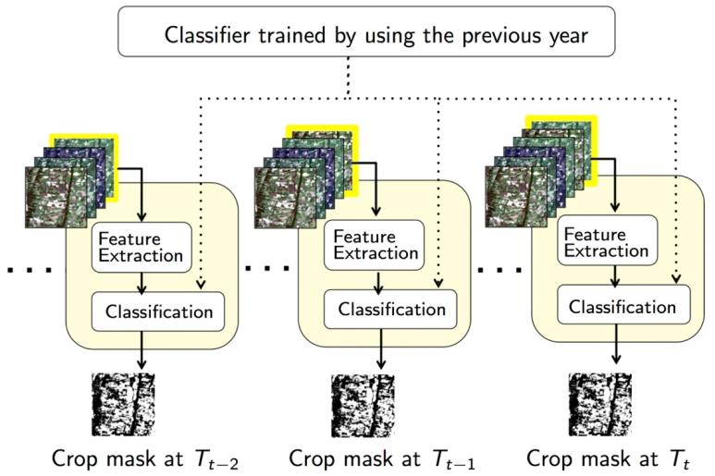

Figure 2‑1. Schema representing the proposed supervised system

### Features characterizing crops used in a supervised dynamic system

Three different well-known spectral index such as Normalized Difference Vegetation Index (NDVI), the Brightness and the Normalized Difference Water Index (NDWI) are used. The interest of using multi-temporal NDVI phenological profiles has been extensively corroborated in the context of crop identification. Global trends are often observed in crop NDVI signatures describing the three most important crop stages: onset of greenness, a period where the maximum NDVI is stable, and the onset of senescence.

Besides the phenological NDVI features, other features concerning other spectral indices not depending on temporal acquisitions have been also proposed. The aim of the incorporation of these features is to better discriminate the land cover classes not included in cropland areas. From these indices, the feature presented in Table 2‑1 are defined and used.

Table 2‑1. Set of features used in the supervised approach

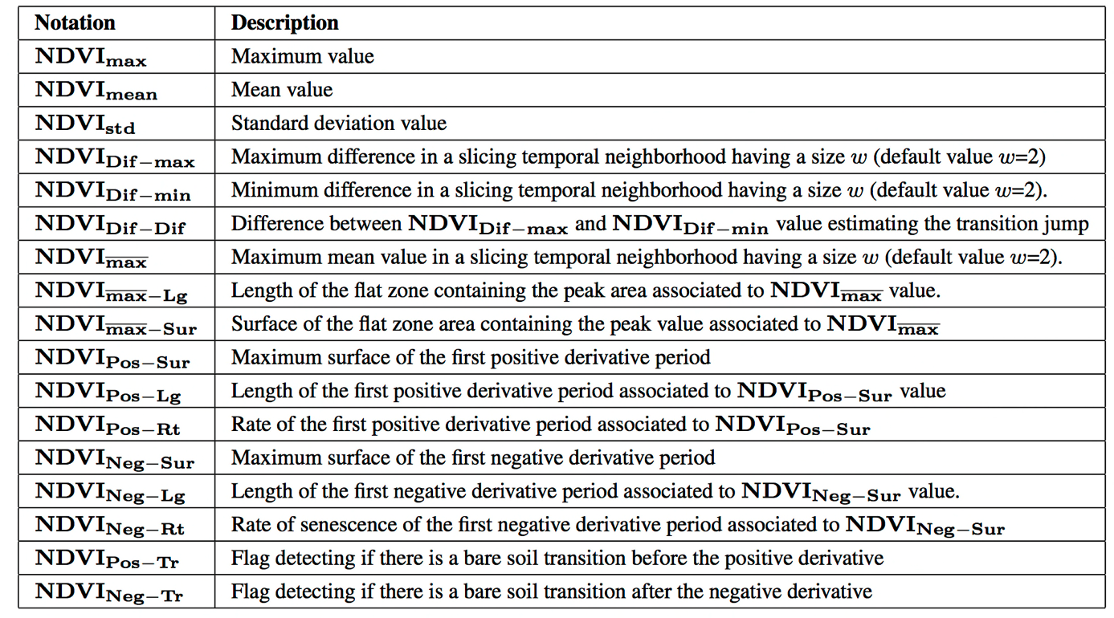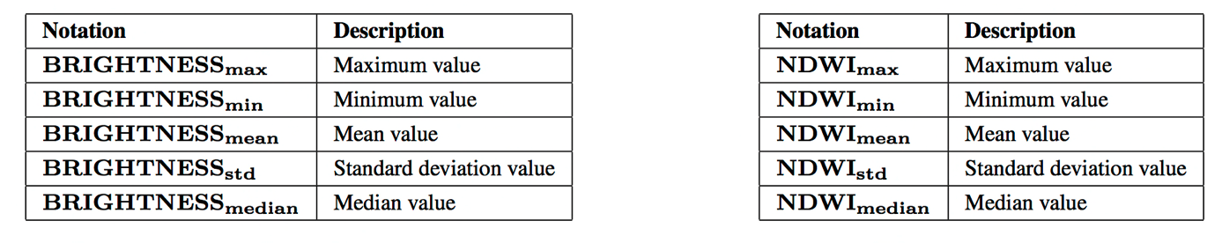

### The choice of the supervised classifier used in a supervised dynamic system

Two of the most well-known supervised classifiers are the Random Forest (RF) and the Support Vector Machine based on a Radial Basis Function kernel (RBF-SVM) classifiers. In terms of complexity, the RF classifier has shown better performances than the RBF-SVM one. For instance, it can be easily corroborated comparing the time that it is spending during the training task for both classifiers. Concerning the overall accuracies, RF has shown better performances that have been corroborated in the exploratory phase. Accordingly, RF classifier is used in the proposed dynamic classification system.

## Unsupervised approach

Supervised classification methods could be considered as the current state of the art, nevertheless they rely on training data. This issue can be a draw-back when the objective is to do early cropland estimation due to the fact that the field data is collected at the end of the season. The need of field data can be also be critical when the objective is classifying large areas (for example when working at national, continental or global scale) where collecting representative and reliable field data would imply huge economic costs.

That is the reason why several unsupervised approaches were tested in this benchmarking: the objective to identify the best set of algorithms that could give an alternative to the need of accurate field data. These approaches are named along the report as “unsupervised” ones even if they are not all unsupervised approaches in a strict way. They include the use of simple rules, the use of thresholds, the use of a classical unsupervised classifier and the use of iterative trimming.

In some of these methods, it is necessary to use a reference map. This reference consists in the best map (raster or vector file, cropland or land cover) available for each of the sites. These references vary from the information relative to crop-non crop extracted from the 2012 farmers’ declaration (RPG) in the French site to the information extracted from the global Land Cover CCI map (<http://www.esa-landcover-cci.org/>) in the Moroccan site. Table 2‑2 lists the information used to create the different references for the test sites.

It must be notice that some of the unsupervised approaches need information regarding the non-crop classes. For that reason, the crop-non crop layer extracted from the RPG (France) or the SIGEC (Belgium) for example were complemented with the Land Cover CCI maps as background layer.

Table 2‑2. Information used to create the references from the different sites

|  |  |
| --- | --- |
| **Site** | **Information used in the reference** |
| Belgium | SIGEC 2012[RD.38], Land Cover CCI [RD.31] |
| Argentina | Global land cover GLC30 [RD.37] |
| Chine | Global land cover GLC30 [RD.37] |
| Ukraine | 2010 classification map ( 30 m) provided by site manager |
| France | RPG 2012[RD.39], Land Cover CCI [RD.31] |
| South Africa | Water bodies SRTM-SWBD [RD.40], SADC Landcover Dataset (2000) [RD.41], Land Cover CCI [RD.31] |
| Maricopa | USDA data layer 2012 [RD.42] |
| Madagascar | Global land cover GLC30 [RD.37] |
| Pakistan | Global land cover GLC30 [RD.37]] |
| Morocco | Land Cover CCI [RD.31] |
| Russia | Fields delineation based in Landsat provided by the site manager, Land Cover CCI [RD.31]. |
| Burkina | Global land cover GLC30 [RD.37 |

### Features selection

A second key step, after building the reference, is the selection of key information that will feed the classifiers to discriminate between what is crop and what is not crop. For that, we selected the input features according to what we know about the growing cycle. Typically, a crop (i) starts growing after tillage from a bare soil, (ii) has higher growing rate than other natural vegetation types, (iii) has a well-marked peak of green vegetation and (iv) has a fast reduction of green vegetation due to harvest or senescence. In addition we looked to select features independent of their timing, allowing dealing with the cropland diversity and the gradient across landscape. Figure 2‑2 shows as example two typical crop growing curves.

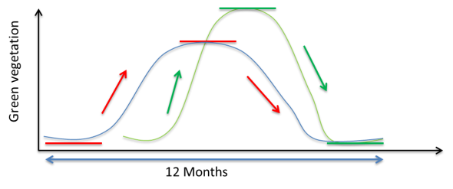

Figure 2‑2. Example showing two typical crop growing curves

### Use of simple rules

The first approach tested in a pre-selection phase consisted in finding a set of rules based on the NDVI time profiles. These rules had to be used either by themselves or as a tool to label the clusters resulting from an unsupervised classification algorithm. After testing this methodology in different sites, the conclusion was that the selection of key NDVI values was not obvious and not necessarily common to the different sites.

Figure 2‑3 (a) shows, as an example, the NDVI profiles of the 50 clusters resulting from an unsupervised Kmeans algorithm applied over the Morocco site using as input the Spot 4 Take 5 (S4-T5) NDVI time series. Figure 2‑3 (b) shows the NDVI profiles of the clusters that were identified as cropland when applying the following set of rules:

* A cluster is cropland if it satisfies the 3 following rules:
* Rule1: Mean NDVI > 0.3
* Rule2: Relative (winter-summer) NDVI < -0.2
* Rule3: Relative (winter-summer) NDVI > 0.2

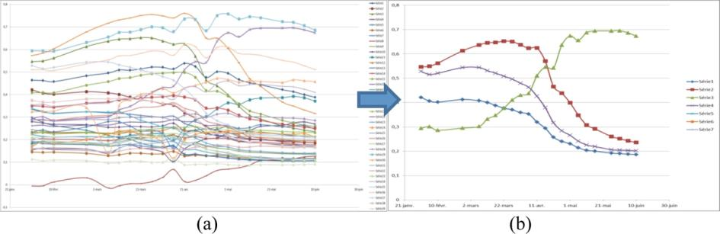

Figure 2‑3. NDVI profiles from the Morocco site of a) the 50 clusters resulting from the Kmeans, b) the clusters identified as cropland

### Use of thresholds

Regarding this method, the first objective was to identify the key characteristics of croplands and parameterize them using the spectral and temporal information we count with. For that, we tested the usefulness of different metrics obtained from temporal profiles of NDVI and of different spectral bands. Table 2‑3 summarizes the rationale under the different metrics that were considered.

Table 2‑3. Summary of the rational under the different metrics considered in the benchmarking

|  |  |  |
| --- | --- | --- |
| **Annual cropland characteristic** | **Metric** | **Parameterization** |
| Annual cropland soil is prepared before the sown. At this moment the soil is bare, being removed all the sparse natural vegetation. | Max red | Cropland max red of the year is higher than the max red of the year of non-annual cropland |
| Annual cropland vegetation grows faster than other natural vegetation, from bare soil to total soil cover. | Amplitude of NDVI | Amplitude NDVI is higher than the amplitude of non-annual cropland |
| Positive NDVI slope | Positive NDVI slope is higher than the slope of non-annual cropland |
| Annual cropland vegetation has a sharp decrease due to harvest | Negative NDVI slope | Negative NDVI slope is lower than slope of non-annual cropland |

Finally, each of the proposed metrics was thresholded using a logistic regression and a reference map as explained previously. As an example, Figure 2‑4 shows the amplitude of NDVI and the mask resulting from thresholding the amplitude of NDVI by logistic regression in area of the study site of South Africa.

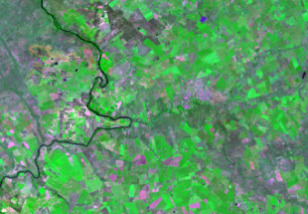 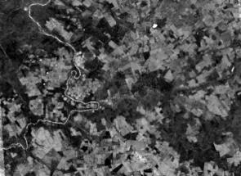 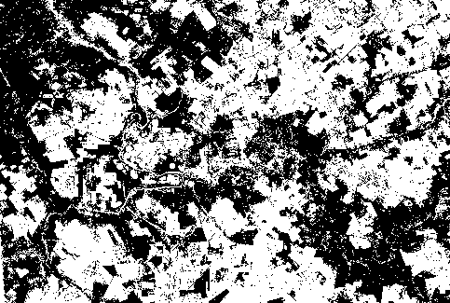

1. (b) (c)

Figure 2‑4. a) Color composite (band 1=blue, band2=red, band3=green) of the S4-T5 image on 31/01/2013, b) amplitude of NDVI, c) resulting mask (white color= crop)

In order to find how combining optimally the different thresholded metrics, 2 sets of maps were produced. In the first one, the cropland area corresponded to the pixels where the thresholds were met for at least 3 out of 4 metrics. In the second one, the four thresholding metrics had to be met.

The accuracies of these 2 sets of maps were computed and analysed. The conclusion was that this simple thresholding approach performed not as well as other methods more sophisticated methods.

### Classical unsupervised approach

This method consisted in using the unsupervised Kmeans classifier and to label the obtained clusters using the reference dataset (Table 2‑2) through a majority voting. Each cluster is superimposed to the reference map and the proportion of each class inside the cluster is calculated. The cluster is labelled with the majority class. This method was implemented with two different sets of input features.

The first one consist in the metrics presented in Table 2‑3 (maximum red, amplitude of NDVI, positive slope of the NDVI vs time curve and negative slope of the NDVI vs time curve).

The second one makes use of the reflectance values extracted from the key moments of the crop growing cycle. As mentioned before (Figure 2‑2), the crop development cycle can be characterized by 4 key characteristics: a crop starts growing after tillage from a bare soil, it has higher growing rate than other natural vegetation types, it has a well-marked peak of green vegetation and it has a fast reduction of green vegetation due to harvest or senescence. Following this conceptual framework, for each pixel, we extracted the dates when the maximum red, the maximum slope of the curve, the maximum NDVI, the minimum slope of the curve and the minimum NDVI were observed. Then, still for each pixel, the (green, red, NIR and SWIR) reflectance values were extracted from these dates and composited. The final features were therefore the reflectance values coming from the dates when a) the red was maximum, b) the slope of the NDVI vs time curve was maximum, c) the NDVI was maximum, d) the slope of the NDVI vs time curve was minimum and e) the NDVI was minimum.

Figure 2‑5 shows a zoom of the reflectance values coming from the minimum NDVI and maximum NDVI of an area from the study site in France

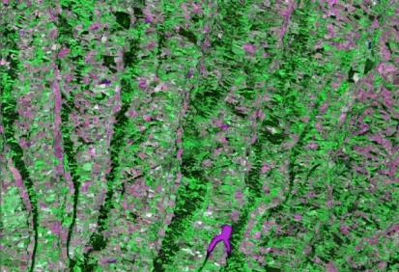 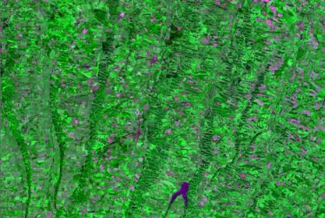

(a) (b)

Figure 2‑5. Color composite (band 1=blue, band2=red, band3=green) a) of the reflectances coming from the minimum NDVI and, b) of the reflectances coming from the maximum NDVI.

The exercise showed that the algorithm was performing clearly better when fed by the reflectance values coming from the key moments of the growing cycle. For example, over the Morocco site, tests with the first set of input features resulted in an OA of 0.23 while it reached up to 0.71 with the second set of features.

### Trimming approach

Trimming consists in truncating a distribution from its least probable values that behave like outliers. The common purpose of this procedure is to reduce the sensitivity to outliers for many parameter estimates, such as the sample mean and variance. As the estimates of the distribution are inﬂuenced by the outliers, the trimming is performed until there is no more outlier. This is what is called an iterative approach.

Two different approaches were performed in this benchmarking, based on the use of such iterative trimming.

The first approach followed the line applied in some deforestation studies which successfully associated the outliers to forest changes [RD.34]. Transposed in our context, the reference map is first used to assign a certain label to groups of pixels and generate a first rough classification of the image. This classification is then cleaned through an iterative trimming which identifies the abnormal values that don’t agree with the assigned label. In a third step, these areas are reclassified by means of a Maximum Likelihood (ML) classifier.

The second approach consisted in extracting training data from the reference map which has been previously cleaned through an iterative trimming and then use this trimmed data for training a ML classifier.

In both cases, the input features were the reflectance values coming from the key moments of the growing cycle as explained before. In order to have a good performance of the trimming algorithm, the dimension of the input dataset had to be reduced, i.e. the most suitable features had to be identified. Different combinations were tested and the best combination proved to be the red and NIR from the moment of the minimum NDVI, and the green, red and NIR from the moment of maximum NDVI. In the future, when using S2 data, it is proposed a new selection of the reflectances for the trimming by for example analysing their correlation or by using a Principal Components Analysis (PCA).

Regarding the two trimming approaches, the second one showed better results especially in the cases when there was no high spatial resolution reference. In this case, the algorithm run using 300 m Land Cover CCI map. Figure 2‑6 shows the different crop masks obtained for an area of the study site of Morocco, figure (a) corresponding to the first approach and figure (b) corresponding to the second one.

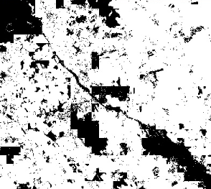 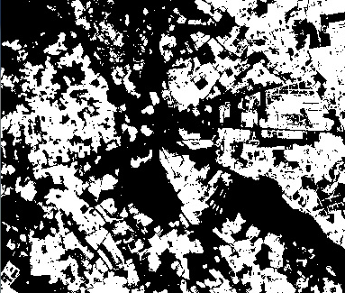 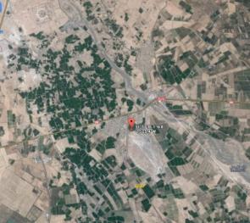

(a) (b) (c)

Figure 2‑6. Crop mask obtained from an area of the study site in Morocco, a) using trimming for change detection and reclassification, b) using trimming for extracting training data, c) google image of the area

## Filtering, smoothing and selecting the spatial unit

In addition to the tests done to identify which are the best methods or classifiers, work was also been carried out on the filtering and smoothing of the reflectance values time series. The main objective of this work was to reduce the noise coming from the pre-processing (for example commission errors in the cloud mask performance) and therefore, to be able to extract the most coherent features.

The filtering method that proved to be the best was the linear regression. Regarding the smoothing, two methods were compared: the use of the average of a moving window of 3 dates and the whittaker approach. The results of testing the two methods showed that the features extracted after smoothing using whittaker were more consistent spatially and that the accuracies obtained from the classifications were slightly higher.

Regarding the spatial unit, the pixel-wise classification results often introduces the salt-and-pepper appearance. This problem appears since the pixel-wise classification does not consider information about the spatial structures. To address this limitation, the classification system should take advantage of the spatial relationship among pixels. In order to include the spatial information in our classification system, a segmentation map of the image has been used under two strategy.

1st Approach : The segmentation is used to filter the image. The filtering step consists in giving the mean value on the region defined by the segmentation map. The goal is to achieve a homogeneous cropland mask. Therefore, the classifier decision is applied on the filtered regions instead of the single pixels.

2nd Approach : The segmentation map is used in order to filter the classification results. In this post-processing task, the regions contained at the segmentation map are used to apply the majority vote decision algorithm. The goal is assign an unique class to the region by using the classifier decision output constructed at pixel level.

The construction of the segmentation map is based on the the Mean-Shift segmentation algorithm. This algorithm is applied on a multispectral image times series. In our case, this image correspond to a set of the six first principal components obtained applying a PCA transformation on the NDVI times series.

## Algorithms to benchmark

As result of the literature review as well as the before explained exploratory phase, the five methods proposed and approved by ESA in the first project meeting (Louvain la Neuve, 10/09/2014) were the following ones:

* Supervised approach, corresponding to the method detailed in section 2.1;
* Unsupervised approach, corresponding to the method detailed in section 2.2.4: Kmeans classifiers to generate clusters and then labelling by majority voting from a reference, input features being the reflectance values coming from the key moment of the growing cycle;
* Trimming corresponding to the method detailed in section 2.2.5: cleaning of a reference through an iterative trimming to get training data and then, using this trimmed data to train a ML classifier;
* *All of them object and pixel based.*

# Criteria for benchmark analysis

Different classical measures have been used in the benchmark analysis :

* **Recall**, which is the fraction of crops (no-crops) correctly classified taking into account all the true crops (no-crops)



* **Precision**, which is the fraction of crops (no-crops) classified as crops (no-crops) which are actually crops (no-crops)



* **F-score**, which is the harmonic mean of precision and recall



* **Kappa**, which measures the relationship between beyond chance agreement and expected disagreement:



* **Overall accuracy**, which is the fraction of crops and no crops correctly classified:



In order to compare the different approaches some consideration have been taken into account.

The algorithms to be benchmarked can be divided in two main groups: the algorithms that need training pixels from the available in-situ data and those that don’t need a priori data. Accordingly, the in-situ data available for the different sites must be divided in two sets:

* 1/3 of the in-situ data will be used for training supervised classifier system;
* 2/3 of the in-situ data will be used for validation.

Therefore, all the proposed methods will be evaluated on the same 2/3 of the in-situ data. In order to avoid results highly correlated with the splitting task of the in-situ data, 10 random splits of the in-situ data will be done for each site. Hence, for each site:

* 10 splits of the in-situ data will be done in order to extract 2/3 of the in-situ data polygons;
* For each experiment, the learning of the supervised classifier will be done with the 1/3 of the polygons not used on validation;
* The mean of the 10 experiments will be compared for the 6 algorithms.

# Benchmark results

Different evaluations have been performed :

1. Evaluation of the object level image representation obtained by the segmentation map
2. Comparison between supervised and unsupervised approaches, where supervised approaches are trained by using in-situ data.
3. Comparison between supervised and unsupervised approaches, where supervised approaches are trained by using a reference map.
4. Comparison of the unsupervised approaches using the complete field dataset.

## Evaluating the object-level image representation

Figure 4‑1 evaluates the segmentation results obtained for the different sites. As it has been previously explained (see section 2.3), the Mean-Sift algorithm is applied on the first 6 PCA components from the NDVI times series. If the number of images composing the image times series is lower than 6, the number of images to choose after PCA, must contain the 99% of the variance of the data. The Mean-Shift parameters used for all the sites were : range radius of 0.65, spatial radius of 10 and minimum object size of 10.

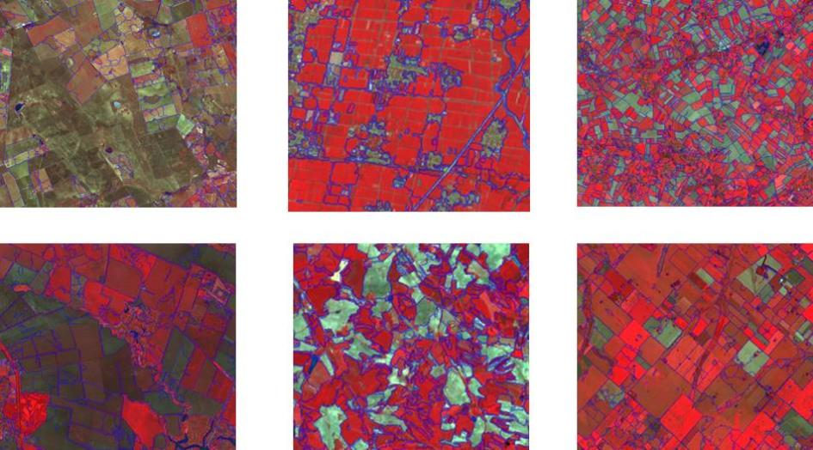

Figure 4‑1. From left to right - First row: South Africa, China, Belgium; Second row: Ukraine, France and Argentina

As it can be seen, the regions defining the segmentation map seem coherent regions. It can be also seen how the different crop parcels can be detected (as for instancein the Belgium segmentation results).

The choice of the spatial radius parameter has been done by analyzing the impact on the classification results. The next figure (Figure 4.2) shows the results obtained by changing the spatial radius value.

Figure 4‑2. Relationship between the spatial radius and the overall accuracy for different sites

## Comparison between supervised and unsupervised approaches : The use of in situ data

The results obtained by using the different approaches tested in the benchmarking were assessed and results are presented in this section. For each site, the cropland masks have been evaluated using the criteria presented in section 3. More precisely, the next algorithms are evaluated:

* **Random Forest –** P**ost-processing segmentation:** The supervised RF classifier has been trained using the pixel level representation of the image. The resulting cropland mask is then filtered using the segments ( the same used in the object-based approach) by means of a majority voting.
* **Random Forest – Pixel :** The supervised RF classifier has been trained using the pixel level representation of the image and the classification model is also applied on the pixel-based image representation;
* **Random Forest – Object :** The supervised RF classifier has been trained using the object-based image representation of the image and the classification model is also applied on the object-based image representation. In the object-based representation, each segment is represented by its mean value.
* **Kmeans – Pixel :** The Kmeans classifier has been fed by the pixel-based reflectance values coming from the maximum red, minimum NDVI, maximun NDVI, maximum and minimum slope of the NDVI/time curve. The resulting clusters are labelled using the references indicated in Table 2‑2.

* **Kmeans – Object :** The Kmeans classifier has been fed by object-based image representation of the reflectance values coming form the maximum red, minimum NDVI, maximun NDVI, maximum and minimum slope of the NDVI/time curve. The resulting clusters are labelled using the references indicated in Table 2‑2.
* **Kmeans – Filter :** The Kmeans classifier has been fed by the pixel-based reflectance values coming from the maximum red, minimum NDVI, maximun NDVI, maximum and minimum slope of the NDVI/time curve. The resulting cropland mask is then filtered using the segments ( same used in the object-based approach) by means of a majority voting.
* **Trimming – Pixel :** An iterative trimming has been performed in order to extract the information needed to train aML classifier. This algorithm uses as input data pixel-based reflectance values coming from the maximum red, minimum NDVI, maximun NDVI, maximum and minimum slope of the NDVI/time curve.
* **Trimming – Object :** An iterative trimming has been performed in order to extract the information needed to train aML classifier. This algorithm uses as input data the object-based image representation of the reflectance values coming from the maximum red, minimum NDVI, maximun NDVI, maximum and minimum slope of the NDVI/time curve.
* **Timming – Post-processing segmentation :** An iterative trimming has been performed in order to extract the information needed to train aML classifier. This algorithm uses as input data pixel-based reflectance values coming from the maximum red, minimum NDVI, maximun NDVI, maximum and minimum slope of the NDVI/time curve. The resulting cropland mask is then filtered using the segments ( same used in the object-based approach) by means of a majority voting.

The obtained results are shown using a chart template. In it, the cropland mask results have been evaluated after the first 3/6/9 months and for the complete year (12 months). These temporal windows are computed from the first acquisition date of the satellite. Therefore, it does not mean that these dates correspond to the beginning of the phenological cycles of the agriculture areas. The number of pixels used to evaluated the cropland mask is shown in the left up corner. For each site, the same samples are evaluated for all the methods.

In the case of the Kmeans-object and trimming-object, just the results using the complete year were computed. The reason of that was the long computation time and the fact that previous tests shown the same dinamic behaviour than the corresponding pixel-based approaches

Concerning the supervised approaches, 1000 crop samples and 1000 no crop samples are used in the classification training step. These samples are extracted from polygons that are not used in the validation task as explained in the last section. In some sites, the use of 1000 samples have not been possible. In that case, the number of trainining samples correspond to the 50% of the total number of samples composing the in-situ data.

Corncerning the unsupervised approaches, no crop samples are used in the classification but a reference map as it is indicated in Table 2‑2.

The precision, recall and the F-score have been computed for crops and for no crops. Two global measures, which are the Kappa and the Overall Accuracy (OA), are shown in the two last columns.

The six studied sites are Belgium , Argentina, China, Ukraine, South Africa and France.

### Belgium

The image times series is composed of SPOT4-Take5 + Landsat8 images. The data set is only composed of 11 images along 11 months. Most of the images contain an important number of clouds.

The number of in-situ data is very large for crop and no crop samples. Next table shows the obtained results. It can be seen how the results are very satisfactory from the 3 first three months.

Table 4‑1 presents the results obtained over the Belgium site for the different approaches.

Supervised approaches obtain the best results.

Regarding the unsupervised approaches, those based in trimming performed better than those based in Kmeans identifying with less precision the non-cropland class. From the methods based in trimming, the trimming-filter seems to be the one that achieves better results, for the overall quality parameters and those related to the cropland class.

Regarding to the dynamic behavior of the different approaches, all of them are able to achieve high accuracy values from the first period (3 months, corresponding to May). That means that at this stage, the different methods count with enough information to be able to discriminate crop from non-crop. The first accuracy values after 3 months are slightly lower , they increase after 6 months staying stable till the end of the period.

Table 4‑1. Assessment of the supervised and unsupervised approaches over the site of Belgium

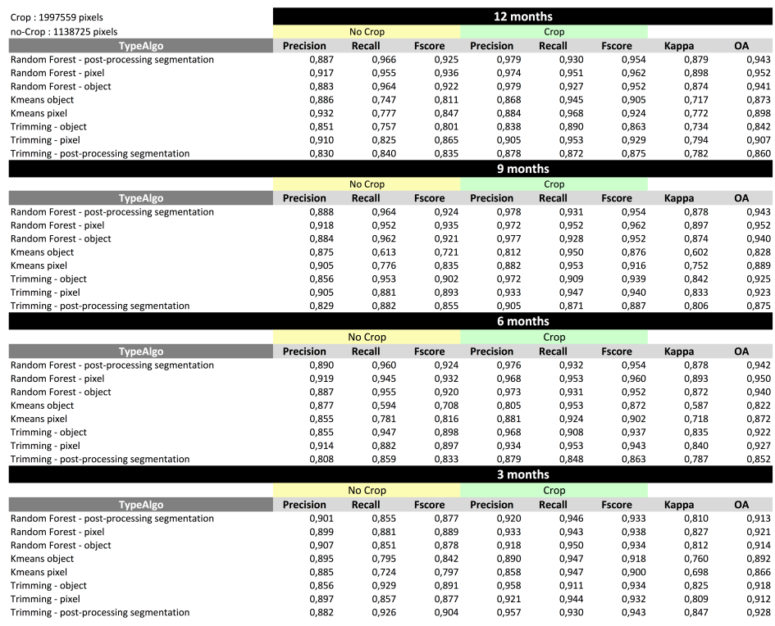

### Argentina

The image times series is composed of SPOT4-Take5 + Landsat8 images.. The temporal resolution is good but it misses the starting of the growing season. The observed area is mostly composed of agriculture fields and some villages. The landscape is well-structured. The number of in-situ data representing crop and no crop areas is balanced.

Looking at the results, it can be observed how supervised strategies obtain better results. Besides, the segmentation post-filtering task give us the best result from the beginning.

Table 4‑2 presents the results obtained over the Argentina site for the different approaches

Table 4‑2. Assessment of the supervised and unsupervised approaches over the site of Argentina

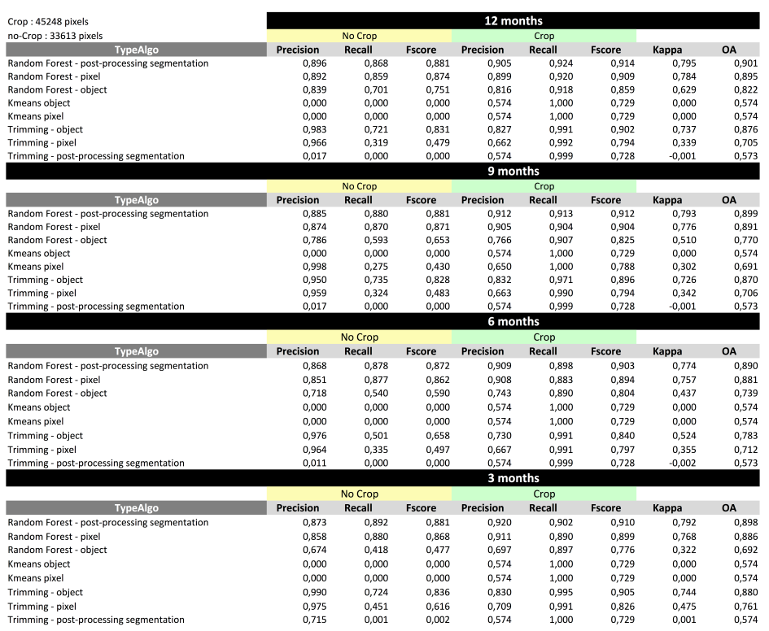

Regarding the unsupervised approaches, the methods based in Kmeans were not able to distinguish the non-cropland, identifying all the pixels as cropland. This may be due to the bad quality of the reference and the few presence of the non-crop class in the scene. In the other hand, methods based in trimming were able to distinguish the two classes (crop and non-crop) in each time interval achieving the highest accuracies for three months. These accuracies decrease when introducing data from the following months. This is due to the fact that the growing cycle ends by the month 3, corresponding to May ( indeed the growing cycle end in April) and after that it starts a new growing cycle with new information that in some cases may be different, consequently adding noise.

Comparing trimming object and pixel based, the object based approach is clearly the best performing in this case.

### China

The image times series is composed of SPOT4-Take5 + Landsat8 images. The number of available images is good. However, most of the images are covered by clouds or aerosols. The diversity of landscape is low since the landscape is mostly covered by fields. The number of samples composing the in-situ data is small. Moreover, it is unbalanced because the number of no crop samples is much more important.

The obtained results are quite good. The quality of the methods using the segmentation result are affected by the presence of aerosols.

The results show that Random Forest – Post-processing segmentation approach obtains better results than Rendom Forest-Object. The use of the segmentation result as a post-processing filtering is more interesting.

Table 4‑3 presents the results obtained over the China site for the different approaches

Table 4‑3. Assessment of the supervised and unsupervised approaches over the site of China

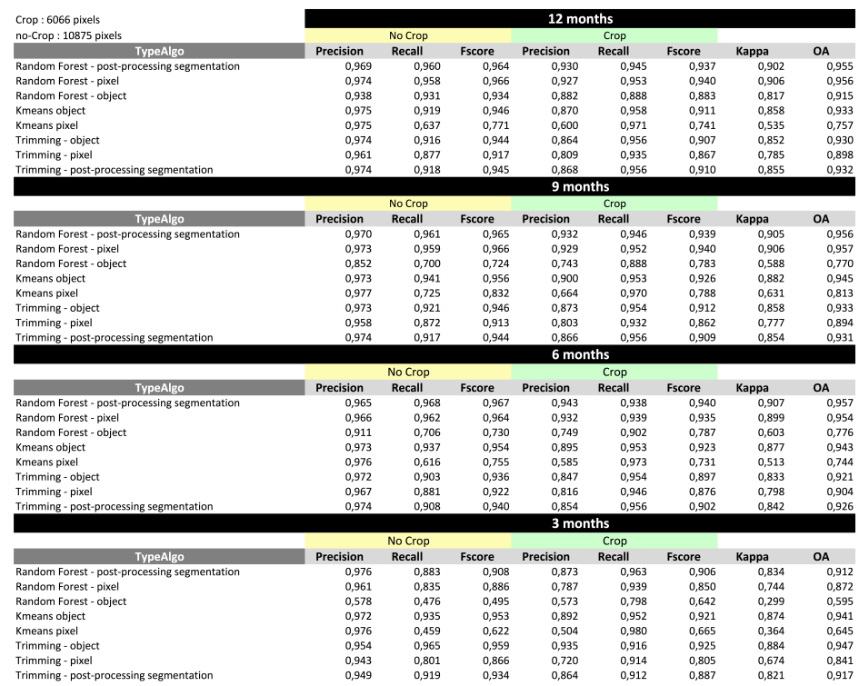

Regarding the unsupervised methods, those based in trimming are performing better especially for the identification of the non-cropland class. The three of these approaches yield similar overall accuracies, being the trimming-filter the one you gets the highest values.

When looking to the dynamic performances, the overall accuracies obtained are high ( 0.84 for trimming –pixel) from the third month, and they increase slightly to achieve the highest values after 6 months for the pixel based approach and after 9 for the object based one.

### Ukraine

The image times series is composed of SPOT4-Take5 + Landsat8 images. The number of images without an important number of clouds is very small. The snow covers a large area of the landscape from February to April. After the snow period, an important cloud period can be observed in the image times series. The landscape is simple, however, the important presence of snow and clouds results in a difficult classification problem. The object-based approaches are quite affected by the presence of snow in the large period of time. The search of homogeneous areas forming the segmentation result can be a difficult task. Despite of the explained before, the results are quite satisfactory.

Table 4-4 presents the results obtained over the Ukraine site for the different approaches

Regarding the unsupervised approaches, all of them seem to achieve similar results with overall accuracies higher than 0.9. From all of them, trimming-object seems to be the one who discriminate better the non-cropland class.

Values are higher than 0.9 from the month 3 being stable for following periods.

Table 4‑4. Assessment of the supervised and unsupervised approaches over the site of Ukraine

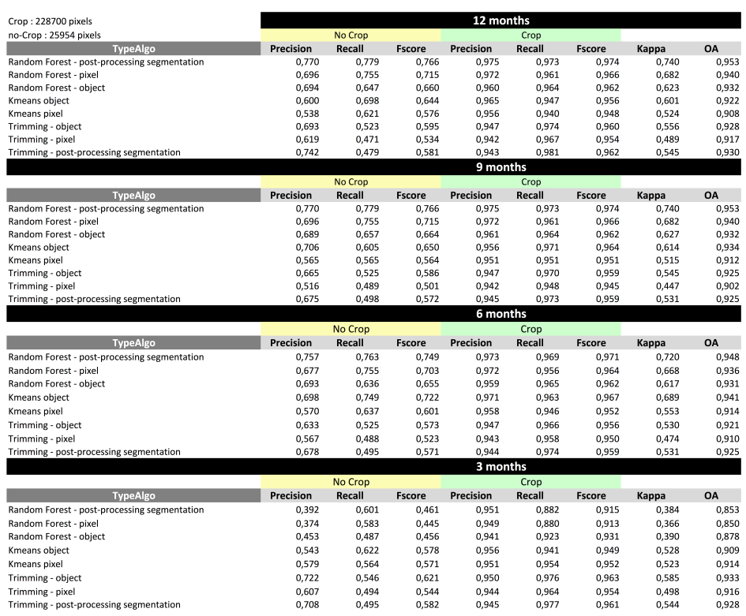

### South Africa

The image times series is composed of of SPOT4-Take5 + Landsat8 images. The temporal resolution is satisfactory even though we miss the starting of the growing cycle. The landscape is quite homogeneous : the presence of natural vegetation is quite low. However, the presence of the complete vegetation cycle of the agriculture fields during the Take-5 period is important.

The number of the samples of the in-situ data is not very high and unbalanced. The number of samples concerning the no crop samples is quite low.

Supervised and unsupervised approaches obtain satisfactory results. However, the results obtained by supervised methods are better than the unsupervised approaches

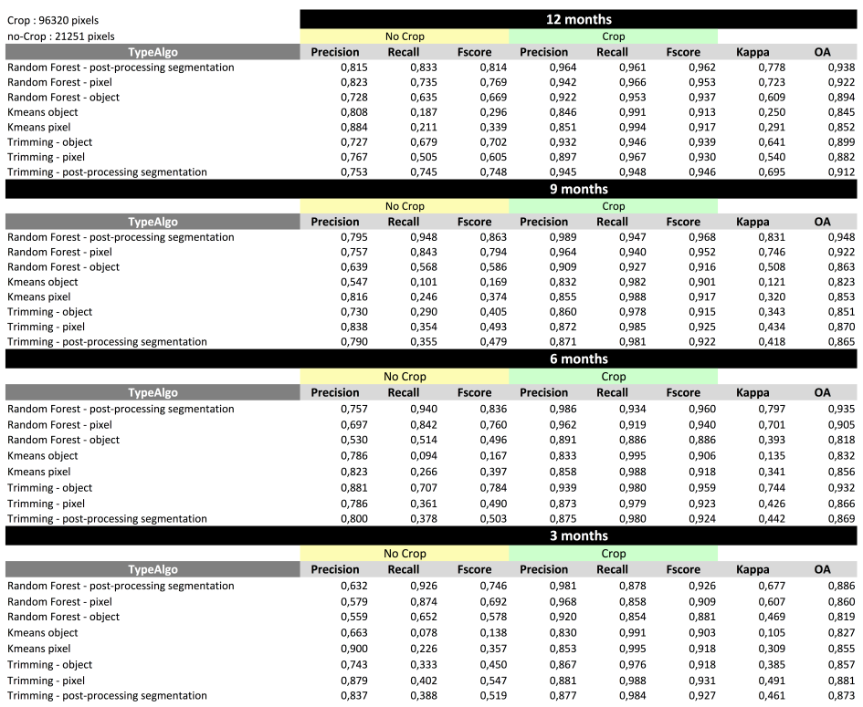Table 4‑4 presents the results obtained over the South Africa site for the different approaches

Table 4‑4. Assessment of the supervised and unsupervised approaches over the site of South Africa

Regarding the unsupervised approaches, those based in trimming perform better especially in the discrimination of the non-cropland class. The overall accuracies obtained with the three of them were very similar, being the slightly higher the one obtained with trimming-filter. Values are higher than 0.85 from the 3th month and stable to the 12.

### France

The image times series is composed of SPOT4-Take5 + Landsat8 images. An important number of images are covered by clouds. However, the temporal resolution of the global data set is quite good. The landscape is not homogeneous at all. On the nord /Center of the image, the landscape is composed of large agriculture fields. In contrast, agriculture fields on the South area ( close to Pyrennes) are quite small.

The in-situ data is good since it is composed by a large number of samples for both classes. The classification results are satisfactory. However, a problem can be seen in the Pyrennes area where a large homogeneous area is classified as crop. This area does not correspond to the crop class. This area corresponds an high altitude area which is mostly covered by snow ( NDVI =0) during the winter and after that, it is covered by clouds.

Table 4‑5 presents the results obtained over the France site for the different approaches

Table 4‑5. Assessment of the supervised and unsupervised approaches over the site of France

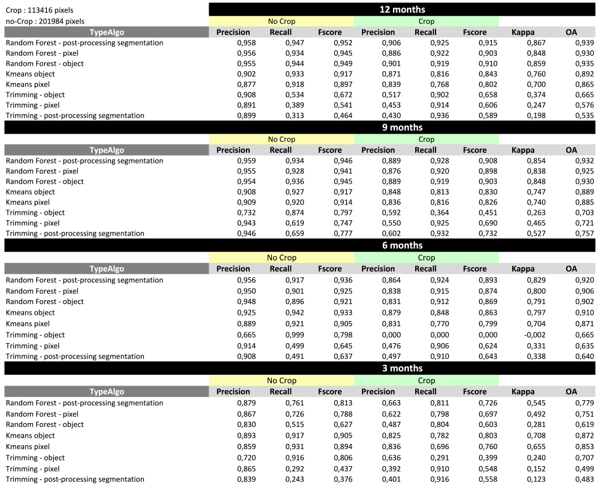

### Regarding the unsupervised methods, the methods based in Kmeans perform clearly better, and from them Kmeans-object is the one that achieves slightly higher accuracies. The best performance is also clearly observed after 9 months, corresponding to November when the algorithms count with all the information relative to the crop growing cycle.

### Maricopa

The image times series is composed of SPOT4-Take5 + Landsat8 images. The temporal resolution is good. The landscape is mostly covered by a desert area and agriculture fields. The agriculture fields are merged between them and they form an important area of the image. The agriculture phenological cycles are very heterogeneous.

The in-situ data covers an important area of the image. The global results are very good.

Regarding the unsupervised methods, for all of them the performances are very good with overall accuracies yielding 1, non-cropland precision yielding 1 and cropland precisions higher than 0.9. From the different methods, the trimming-filter is the one that identifies slightly better the cropland. Regarding the dynamic performance, the first accuracy results after 3 months are slightly lower than those obtained afterwards and from 6 months are stable.

Table 4‑5 presents the results obtained over the Maricopa site for the different approaches

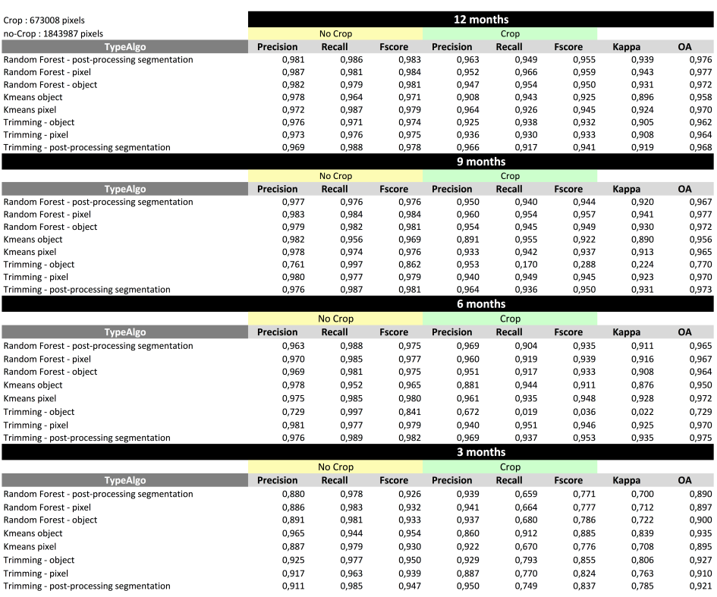Table 4‑7. Assessment of the supervised and unsupervised approaches over the site of USA

### Madagascar

The image times series is composed of SPOT4-Take5 + Landsat8 images. The temporal resolution is acceptable. The West image area is often covered by clouds. The landscape is mostly covered by forest area. The presence of agriculture fields is low. Moreover, the size of agriculture fields are very small. Therefore, it is difficult to discriminate these fields having a spatial resolution of 20 m.

The number of in-situ data is quite low (less than 1000 for each class). Furthermore, most of the in-situ data represent 2 pixels of the image. Besides of these limitations, the results are quite satisfactory.

Table 4‑5 presents the results obtained over the Madagascar site for the different approaches

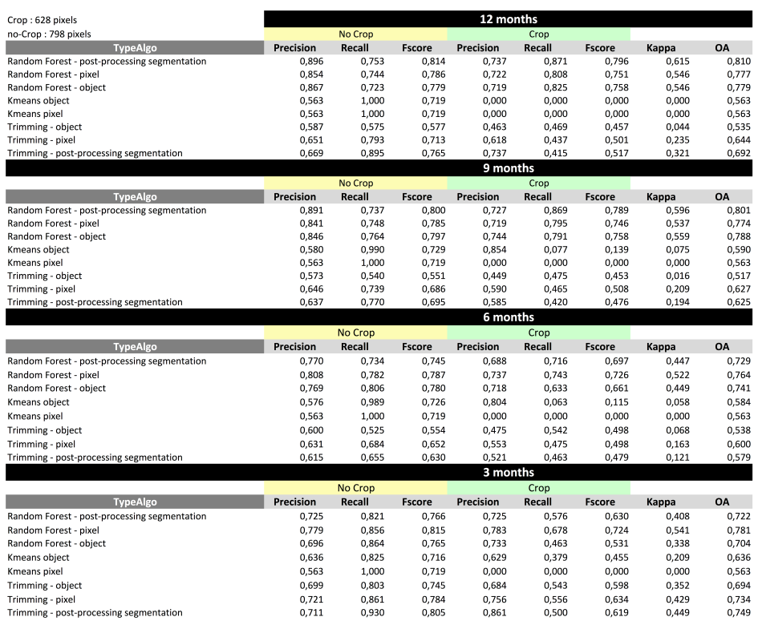Table 4‑8. Assessment of the supervised and unsupervised approaches over the site of Madagascar

The accuracy values obtained by the unsupervised methods are low, being the method that performs better the trimming-filter with values yielding 0.7.after 12 months. Highest values are obtained after 3 months when the growing period ends to start a new one after that. In this case the methods based in Kmeans were not able to distinguish the cropland class. This may be due to the bad quality of the EO dataset, the extremely small fields with areas lower than 0.03 ha and the presence of sparse trees on them.

### Morocco

The image times series is composed of of SPOT4-Take5 + Landsat8 images. The temporal resolution is very good. The landscape is mainly composed of mountains and desert areas.

The number of in-situ data is quite good. However the number of the samples are completely unbalanced. The number of no crop samples is very high. This factor has an important influence in the global accuracy measures since they are computed by taking into account the total number of pixels.

For instance, the overall accuracy is high (around 0.95). However, if we look to the results obtained for the crop class, they are worst. The problem of this measure is that the crop samples which are not well-classified do not impact no crop results.

Regarding the quality values obtained for the unsupervised methods, the method trimming-object is the one that achieves higher overall accuracies. Nevertheless when looking to the quality parameters relative to the crop and non-crop classes it can be noticed how trimming –object and trimming-pixels achieve considerably lower precision values. The explanation of that may be the fact that, in one hand our reference do not separate between annual cropland and fruit trees including both in the same class but in the other hand we do this difference in our validation dataset. In addition most of the fields of the area are fruit threes. When considering this issue and analyzing visually the results, the methods based in trimming seem to perform better than those based in Kmeans. Figure 4.3 Shows an example an image of the study site of Morocco from March, the corresponding cropmask obtained with the method trimming-pixel and the one obtained using the method Kmeans-pixel.

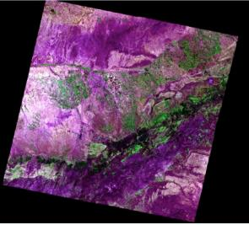 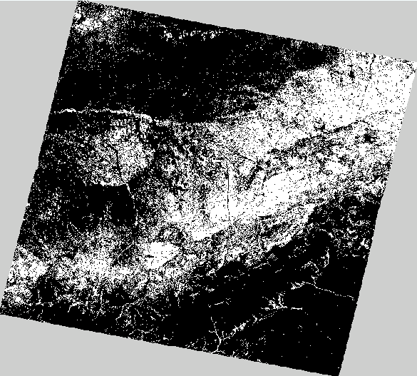 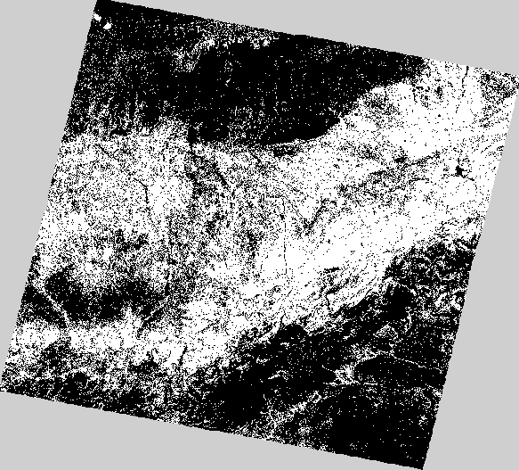 (a) (b) (c)

Figure 4.3. a) Color composition from Morocco, b) Cropland mask obtained by *<<Trimming – pixel>>* method, c) Cropland mask obtained by *<<Kmeans – pixel>>* method

Table 4‑5 presents the results obtained over the Morocco site for the different approaches

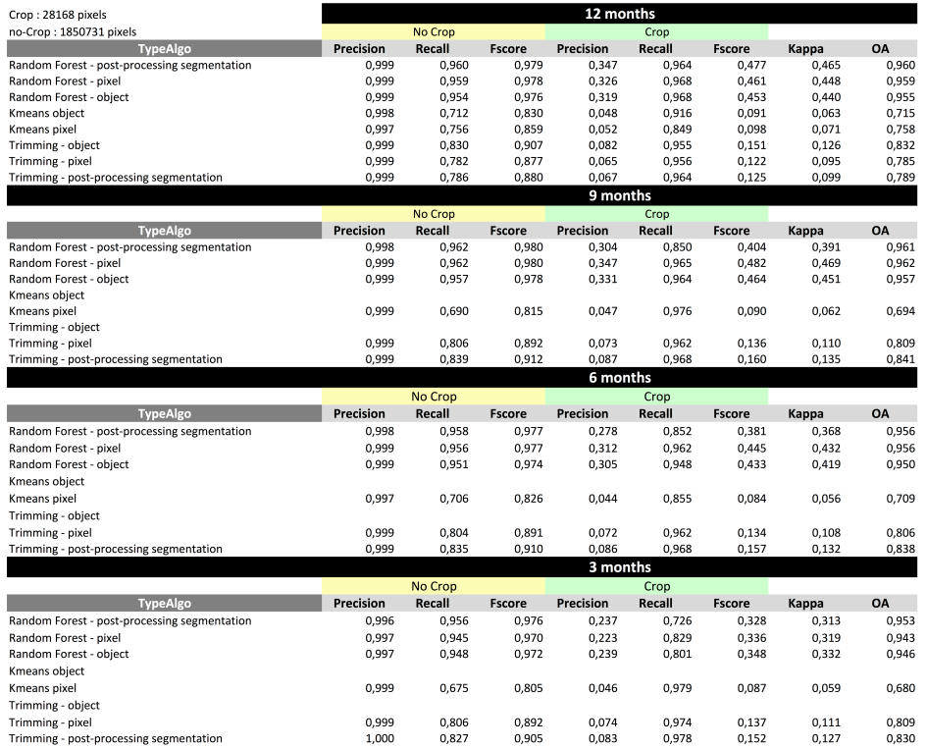Table 4‑9. Assessment of the supervised and unsupervised approaches over the site of Morocco

### Burkina

The image times series is only composed by Landsat8 images. The number of available images is quite low. The image times series only covers 8 months. Besides, most of the images are covered by an important number of clouds.

The number of samples forming the in-situ data is small. For instance, the number of samples for no crop class is around 330 pixels. This implies that only 165 pixels are used for the validation. Accordingly, the validation can not correctly represent all the image.

The size of agriculture fields are very small. Consequently, the photo-interpretation of these fields is not straightforward having a spatial resolution of 20m.

Table 4‑5 presents the results obtained over the Burkina site for the different approaches

Table 4‑10. Assessment of the supervised and unsupervised approaches over the site of Burkina Faso

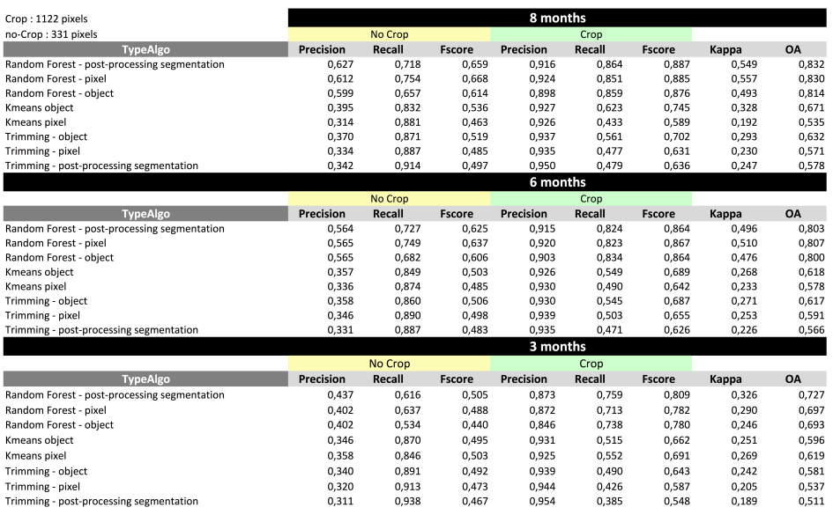

Regarding the unsupervised methods, Kmeans-object and after that Trimming object are the methods that perform better with almost similar accuracy values. That is slightly lower after 6 months to yield the maximum values after 9 and decrease slightly after 12, due to the mixed information with the new growing cycle. Both methods Kmeans object and Trimming-object achieve low overall accuracy values, between 0.6 and 0.7. Several factors contribute to these results like the bad quality period of the EO dataset (with very few images during the growing), the small size of the fields ( less than 3 ha) and the agricultural practices ( presence of trees sparse in the agricultural fields).

### Russia

The image times series is composed of Landsat8 + RapidEye images. The temporal resolution is small. Besides, most of the images have an important number of clouds and snow areas. For instance, clouds cover 90% of images captured from May to October.

The number of samples forming the in-situ data is unbalanced. The crop samples are ten times more important. The overall accuracy is good, however, the Kappa index is small. The interpretation of the results is not easy given the important difference between the number of samples.

The overall accuracy is better using the object-based approach, however, the number of no crops well-classified is worst using the object approach.

Table 4‑5 presents the results obtained over the Madagascar site for the different approaches

Table 4‑10. Assessment of the supervised and unsupervised approaches over the site of Madagascar

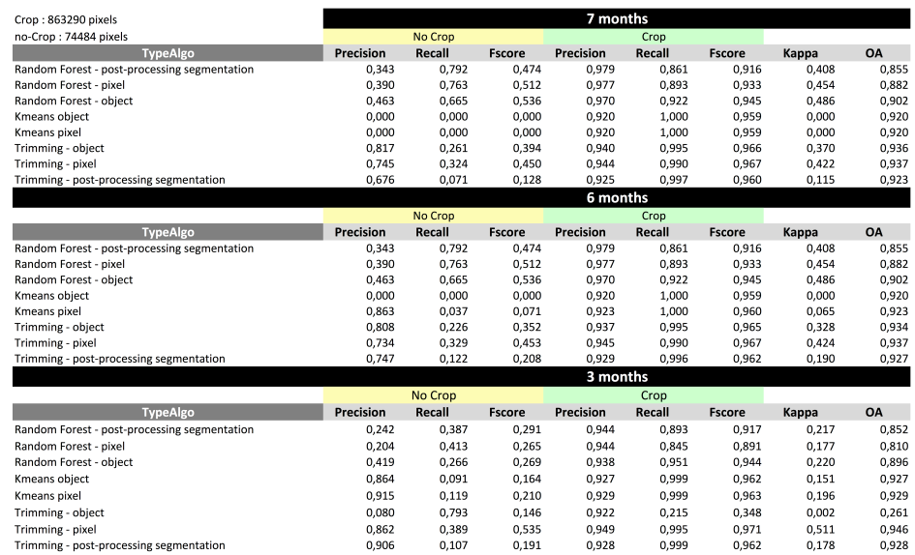

Regarding the unsupervised methods,, methods based in Kmeans are not always able ( after 12 months case) to distinguish between crop and non-crop while methods based on trimming where able to identify crop and non-crop with precisions higher than 0.7 in the case of non-crop and higher than 0.9 in the case of cropland. Trimming-object achieves slightly higher accuracies than trimming-pixel, while trimming-filter performs clearly worst. Overall accuracy values are practically stable for all the timing intervals being slightly higher for the 6th month..

### Pakistan

The image times series is composed of Landsat8 + RapidEye images. The number of images is very low after the 25th May. The presence of aerosols is very important and it has an important effect in the results.

The number of samples composing the in-situ data is low. The results are less satisfactory, for instance, the overall accuracy is 0.82 and the Kappa is 0.64 using the Random Forest-pixel.

The object approach can have some problems because the segmentation is affected by the presence of aerosols.

Table 4‑5 presents the results obtained over the Pakistan site for the different approaches

Table 4‑12. Assessment of the supervised and unsupervised approaches over the site of Pakistan

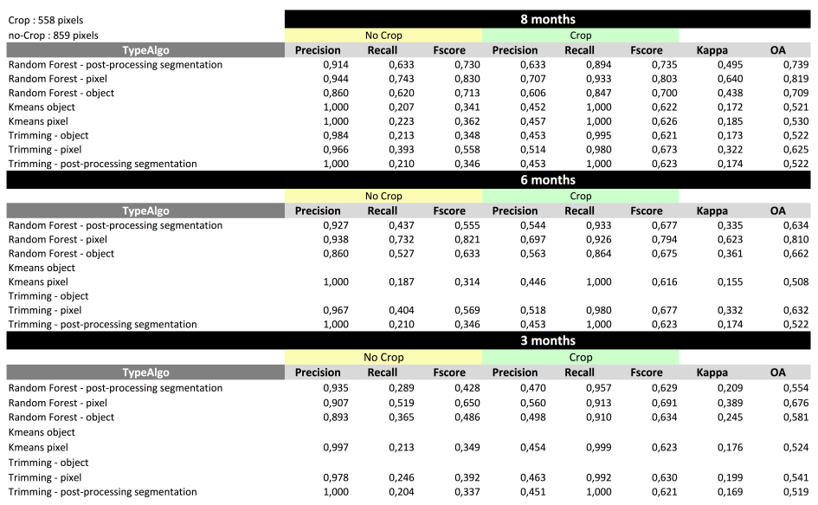

Regarding the unsupervised methods, trimming-pixel and trimming-object were those with the best balance between crop-land and non-cropland precision. Being trimming-pixel the one that performs better. Highest accuracy values are obtained after 9 months.

### Conclusions

Some conclusions can be done by looking at the results presented in the previous tables. Comparing supervised versus unsupervised approaches, the current results show that supervised approaches obtain better results.

Unsupervised approaches have more difficulties to detect no crop pixels. In fact, these approaches tends to classify the unkown pixels as crops. It explains why unsupervised approaches obtain a high crop recall measure. Looking at the evolution of the results along the time, it can be seen how the results improve along the year. The results tends to increase obtaining accuracies higher that 0.8 after 6 months and higher than 0.9 at the end of the year.

Concerning the unsupervised approaches, in general trimming works better than Kmeans and in particular, the object-based approach seems to have better performances. Main limitation of the Kmeans has been observed in Argentina where the no crop class was not identified in some periods, resulting in a map where all the pixels were identified as cropland. This was probably due to the fact of having a reference where there are not enought pixels of not crop, needed to correctly label the resulting clusters (done by mayority voting).

Comparing the supervised approaches, <<*Random Forest – pixel>>* and <<Random Forest – combine>> obtain better results than <<Random Forest – object.>> The problem of this last approach is that using the filtered image during the training process, the variability of the training data is very small. It must be remembered that only 1000 samples belonging to the 1/3 of the polygons have been used in the training. Note that if the polygons form a region in the segmentation map, all the pixel values will have the same value : the mean value of the region.

This problem can be solved by using the <<Random Forest –Post processing segmentation>>.

Using this approach, the results are less affected by the well-known “salt & pepper” classification noise. The use of the segmentation as a post-processing filtering allows to have more homogeneous results and it keeps the good performances obtained by the <<*Random Forest – pixel>>* approach.

Accordingly, The results obtained by <<*Random Forest – pixel>>* and <<Random Forest – Post processing segmentation>> are quite similiar. However, <<*Random Forest – pixel>>* seems to obtain better numerical results. In contrast, looking at the cropland mask images, we can see that the object approach has removed the small isolated pixels which do not belong to cropland mask. Therefore, it is difficult to evaluate if <<*Random Forest – pixel>>* is a better approach. This can be corroborated by looking at Figure. 4-2.

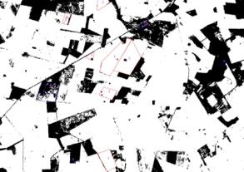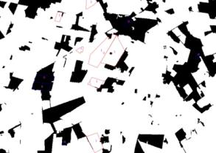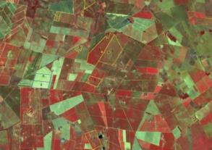

Figure 4‑2. From left to right - RGB Color composition from South Africa.. Cropland mask obtained by *<<Random Forest – post-processing segmentation>>* method. Cropland mask obtained by *<<Random Forest – pixel>>* method

One limitation of the object-based approach can be seen the in Ukraine data set. This data set contains snow areas during a period of the year. Unfortunately, the snow areas appears as a region in the segmentation map. This is normal since these regions have the same spatial-temporal behaviour during the year. However, as the segmentation map is used in the filtering pre-processing, the resulting image obtain mean values in the region which are not interesting. The problem is that the mean filtering is applied on a snow region that can include crop and no crop areas.

However, considering that the spatial resolution of Sentinel-2 will be better than Landsat-8. The <<Random Forest – Post processing segmentation>> has been retained as the best approach. However, it should be remarked that this method needs in-situ data in order to construct the cropland mask. In contrast, unsupervised methods only need a reference map from a data-base previously constructed .

This limitation gives us to the next solution : If the in-situ data is available, we will use a supervised approach. In contrast, if in-situ data is not available, we will use unsupervised Trimming approach.

In order to corroborate our proposal, another important test has been performed. The goal of this test is to check if it is possible to use supervised approaches by using also a reference map coming from a data-base. This experiment is presented in the next Section 4.3.

## Comparison between supervised and unsupervised approaches : The use of reference maps

In the previous section, the supervised methods have been training and testing using in situ data. In contrast, unsupervised methods use external global reference maps in order to obtain the cropland mask. In order to evaluate the importance of the data used during the training step in the supervised methods, a new test is done in the following.

In this new test, we would like to compare supervised and unsupervised methods performed at the pixel-level representation (Table 4.13). Concerning the unsupervised methods, the Trimming-pixel method is compared against the Random Forest-pixel supervised approach.

The Random Forest-pixel supervised approach is training by using the reference maps explained previously in Section 2.2. The supervised and the unsupervised approaches are validated by using the in-situ data.

Concerning the reference maps, they are composed of millions of pixels. Accordingly, in order to use this reference maps in the training process, the 50% of samples forming the reference map are selected randomly. From the resulting data, 1000 crop and no crops samples are used in the training step. The selection of this samples is also randomly performed.

In order to perform an accurate evaluation, 10 different selections are done to split the reference maps in two parts. Besides, for each data set, 10 different test have been performed in order to obtain the 1000 crop and no crop samples. For this reason, the results presented in the next Table show the mean, the minimum, the maximum and the standard deviation obtained for all the different tests. The two methods that have been evaluated correspond to :

* **Random Forest – Pixel :** The supervised RF classifier has been trained using the pixel level representation of the image and the classification model is also applied on the pixel-based image representation;
* **Trimming – Pixel :** An iterative trimming has been performed in order to extract the information needed to train aML classifier. This algorithm uses as input data pixel-based reflectance values coming from the maximum red, minimum NDVI, maximun NDVI, maximum and minimum slope of the NDVI/time curve.

Table 4‑12. Assessment of the supervised and unsupervised approaches over the different sites

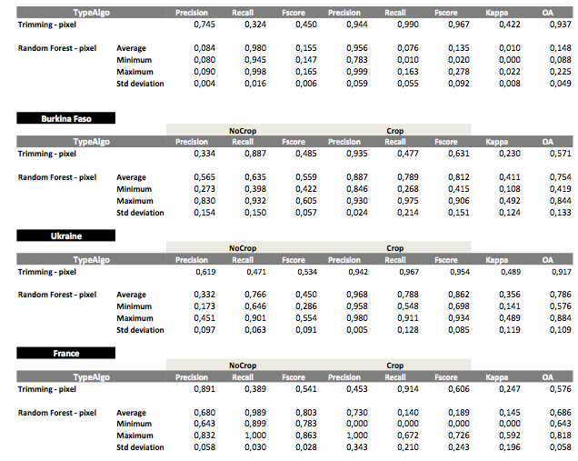

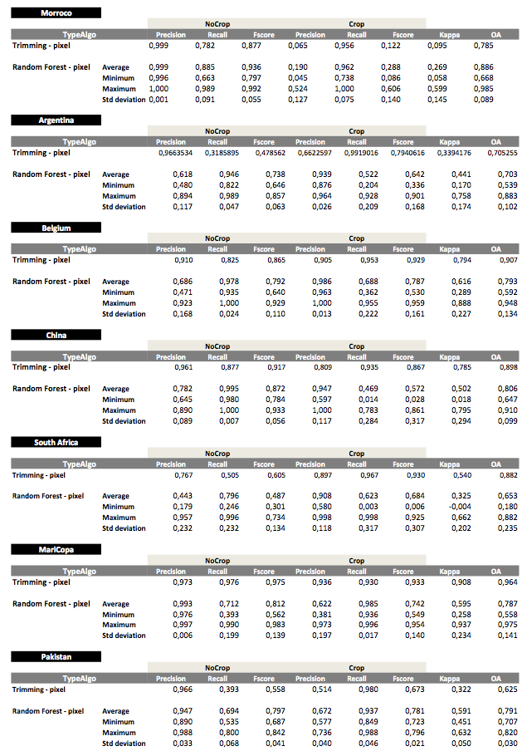

The use of the supervised approach Random Forest-pixel has obtained interesting results. The mean accuracies can be compared with the unsupervised approach obtaining similar or better results in most of the cases.

Unfortunately, the use of the Random Forest-pixel has shown an important limitation against the trimming-pixel method. The results shown that the supervised approach can obtain very good results, however, these results can strongly depend on the splitting done randomly on the reference map. This can be corroborated by looking at the standard deviation obtaining by the different experiments. The maximum and the minimum accuracy values can be very different as it shown the results of the previous table.

In contrast, the unsupervised approach is more much stable than supervised approach since all pixels remaining from the trimming can be directly used to compute the crop land mask, giving the complete information of the class distribution.

## Comparison between the unsupervised approaches using the complete field dataset

As a complementary analysis, the results obtained using unsupervised approaches (KMeans and trimming) were validated once again using all the available field dataset. Indeed, as these methods did not use any field data for training, it allows using the complete dataset for obtaining statistics as robust as possible.

Figure 4‑3 shows the accuracies obtained using the Kmeans and the methods based in trimming, using the data after 12 months from the beginning of the S4-T5 campaign.

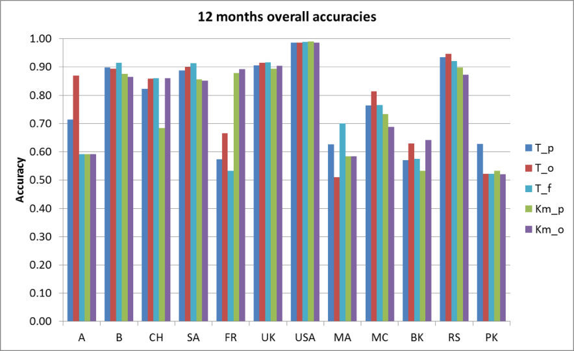

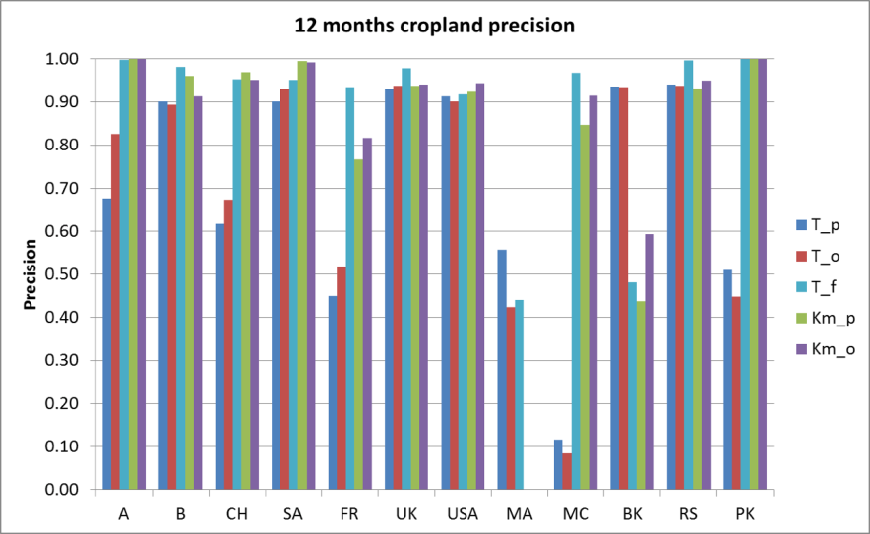

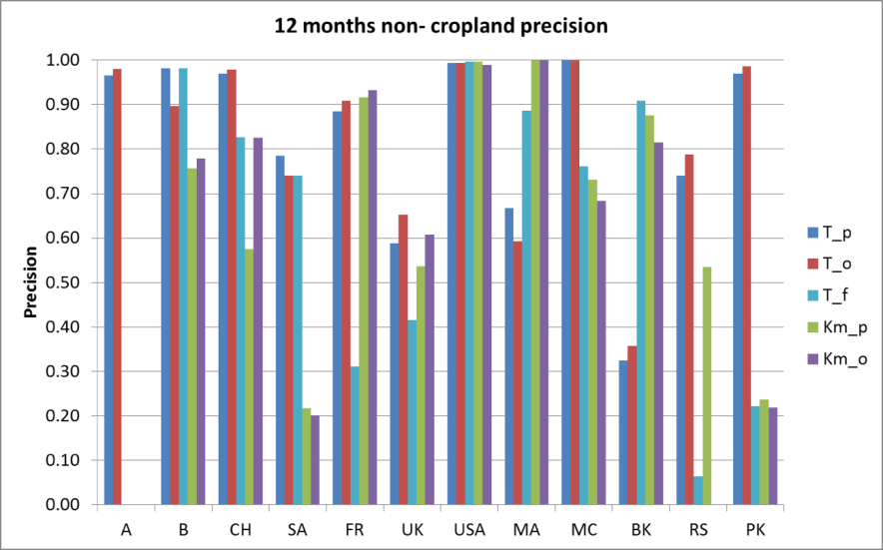

Figure 4‑3. Accuracies obtained using the method based in trimming object (T_o) and pixel (T_p) based, the method based in trimming using the segmentation for filtering (T_f), and the kmeans object (Km_o) and pixel (Km_p) based.

As summary of Figure 4‑3, it could be said that the trimming-based methods perform generally better than the ones using the KMeans. Indeed, the approaches based in KMeans seems to perform well obtaining similar ( or even better in the case of France) overall accuracies than the approaches based in trimming for the sites that count with a detailed reference as it is the case of France , Belgium, USA, or Ukraine. Nevertheless, in the cases where the reference is a global product, and especially where there is few variability of classes inside the area (being the most of the area cropland), the algorithm is not able to distinguish the non-cropland, identifying all the pixels as cropland. This is what happens in Argentina and Russia and partially in Pakistan and South Africa. The effects of that can be seen in the graphs corresponding to cropland and non-cropland precisions of the Figure 4.3 where we obtain high values of cropland precision but cero ( or low values for the case of Pakistan and South Africa) for the non-cropland. In the case of Madagascar is the cropland what it is not identified, probably due to the small size of the agricultural parcels (Mean field size: 0.03 ha)

However, methods based in trimming were able to distinguish cropland from non-cropland in all the sites with different accuracies depending of the quality of the EO dataset, the size of the fields, the quality of the reference, etc…. The overall accuracy obtained for 6 (Belgium, China, Ukraine, Maricopa and Russia) of the 12 sites was higher than 0.8, including the site of Maricopa with values close to 1. In all of these cases the precisions for cropland and non-cropland were balanced. The overall accuracies obtained in Argentina and Morocco were higher than 0.7. Nevertheless, for Morocco, the cropland precision is very low. This can be due to the fact that we consider in our validation just annual cropland, i.e. herbaceous cropland, not including fruit trees or shrubs that are the main croplands of Morocco. In the other side, the reference includes all type of cropland (annual and tree crops) in a single class and we train the classifier with this mixed information.

The lowest accuracies are obtained for the sites in France, Burkina, Pakistan and Madagascar. The case of the site of France is currently under research in order to detect possible inconsistencies in the intermediary steps of the processing chain. For Burkina, Pakistan and Madagascar, 3 factors may be the cause of the results obtained. First, the mean size of the agricultural parcels, extremely small in the case of Madagascar (0.03 ha), 1 ha in Pakistan and less than 3 ha in Burkina; second the low quality of the EO dataset that counts with very few images in the main stages of the growing period; and third, the presence in Burkina Faso and Madagascar of sparse trees in the agricultural parcels.

In the following section it is show how the use of the global land cover CCI instead of the GLC 30 improves considerably the results for this three sites, The accuracies achieved using CCI land cover where 0.83 for Burkina, 0.75 for Pakistan and 0.83 for Madagascar, the last one including in the reference a mixed class between trees and herbaceous cropland for cropland characterization.

Regarding the spatial unit, the accuracies obtained with the object-based approach are better for most of the cases except for Pakistan and Belgium. Nevertheless, in most of the cases the differences are very small. The main drawback of using object-based consists in the computing time, which is double to the pixel-based.

In the case of pixel –based we also count with aesthetic problems due to individual pixels identified as one class different than the surrounding pixels, this problem can be solved as named before by using the objects as last step of the processing chain for filtering the resulting mask. The results of the use of this technic are in general similar or slightly better than the results of the pixel-based, except in the cases of Argentina, France or Pakistan. Figure 4.4 shows for the site in Ukraine, the aesthetic effect of filtering the final pixel-based mask (Figure4-4 a) using the segments.

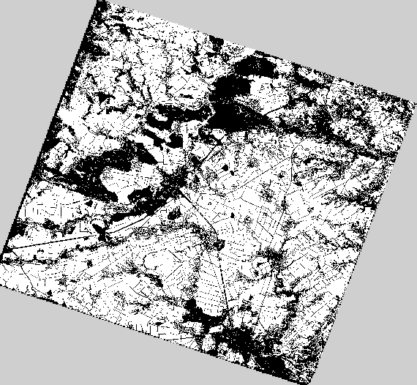 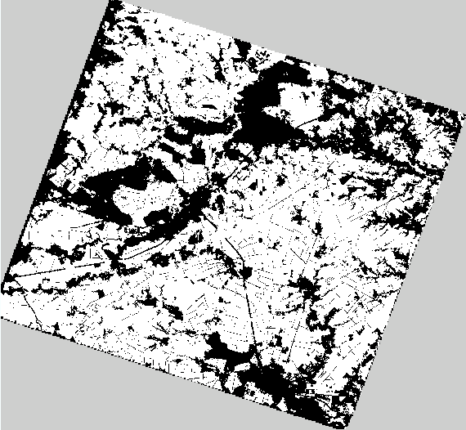

Figure 4‑4. a) Resulting cropland mask using the method based in trimming object based for Ukraine, b) filtered cropland mask using the segments and applying a majority voting.

As explain in previous sections, the different methods have been computed along the season in order to see their dynamic performance. As summary of what was shown in the previous section, and computed using all the filed dataset for validation, Figure 4‑ shows the evolution of the performance along the year (from 3 to 12 months from 1 of February) for the per-pixel trimming method. The results of the sites in Pakistan, Burkina and Russia are not included in the figure due to their short EO temporal dataset.

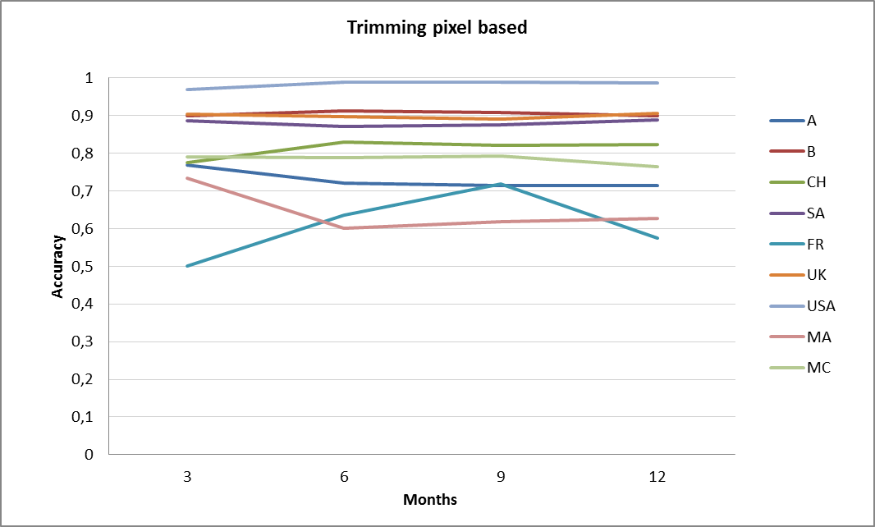

Figure 4‑5. Accuracies obtained for the different study sites along the time, using the method based in trimming object based.

Regarding the different time intervals, for the Northern hemisphere sites, the maximum accuracies are generally obtained 9 months after the start of the S4-T5 mission. This means that the best performances are generally yielded in November when the growing cycle just ends.

An interesting result illustrated in the graphs is that, from the beginning of the experiment (i.e. 3 months), the method is able to produce cropland masks with accuracies higher than 0.7 for all the sites except for the site in France and Madagascar. In the graph, we can see how for the sites located in the northern hemisphere we start getting slightly lower accuracies that increase for the following period ( 6 months, corresponding to October) , from this moment the obtained values are stable indicating that by this time we have all the information characterising cropland. In the case of the sites located in the south hemisphere, (SA: South Africa and MA: Madagascar) we can see how at the beginning we obtain the highest accuracies and from this moment the values start to decrease. This is due to the fact that the growing cycle ends by the month 3 and after that it starts a new growing period with new information that in some cases may be different, consequently adding noise.

## Impact of the reference

In this report, the methods that are named unsupervised are those that use a reference to train a classifier or to label the resulting clusters of a KMeans. A priori, as detailed in the section 2.2, we built up this reference using the best information available for each of the sites.

In this section we wanted to do an analysis of the impact of the reference in the resulting cropland mask. For that, we compared the results of the method based in trimming (pixel based) from the sites that counted with high resolution references as the cases of Belgium, Ukraine, South Africa and Maricopa with the results obtained using the mean resolution global land cover CCI. Results are showed in Table 4.14 Indicating the small impact of the reference in the accuracies obtained for the resulting cropland mask. Indeed, these accuracies could be considered equivalent. This result opens the possibility of using just one single global land cover for all the sites, simplifying notably the system.

Table 4.14. Accuracies obtained using the high resolution reference and the CCI one.

|  |  |  |  |  |  |  |
| --- | --- | --- | --- | --- | --- | --- |
| **Site** | **Overall**  **accuracy** | | **Cropland**  **precision** | | **Non-cropland precision** | |
| **high resolution** | **CCI** | **high resolution** | **CCI** | **high resolution** | **CCI** |
| **Belgium** | 0,898 | 0,909 | 0,901 | 0,932 | 0,982 | 0,871 |
| **South Africa** | 0,888 | 0,890 | 0,901 | 0,906 | 0,784 | 0,777 |
| **Ukraine** | 0,905 | 0,911 | 0,931 | 0,924 | 0,589 | 0,677 |
| **Maricopa** | 0,986 | 0,982 | 0,913 | 0,860 | 0,993 | 0,995 |

In addition, we compared the results obtained for the sites that used the 30 m resolution global land cover GLC30 with the results obtained using the mean resolution (300 m) CCI. This was done for Argentina, Burkina Faso, Pakistan, Madagascar, Russia and Morocco. As illustrated in the Table 2-2, in most of these cases we choose a priory the use of GLC30 in order to have more detailed information. Results of the comparison are shown in Table 4.15.

Table 4.15. Accuracies obtained using the GLC 30 as reference and using the CCI.

|  |  |  |  |  |  |  |
| --- | --- | --- | --- | --- | --- | --- |
| **Site** | **Overall**  **accuracy** | | **Cropland**  **accuracy** | | **Non-cropland**  **accuracy** | |
| **GLC 30** | **CCI** | **GLC 30** | **CCI** | **GLC 30** | **CCI** |
| **Argentina** | 0,714 | 0,695 | 0,676 | 0,674 | 0,965 | 0,797 |
| **Burkina** | 0,570 | 0,838 | 0,936 | 0,842 | 0,324 | 0,794 |
| **Pakistan** | 0,628 | 0,751 | 0,510 | 0,855 | 0,969 | 0,855 |
| **Madagascar** | 0,627 | 0,584 | 0,557 | 0,000 | 0,667 | 0,584 |
| **Russia** | 0,935 | 0,937 | 0,941 | 0,945 | 0,740 | 0,742 |
| **Morocco** | 0,707 | 0,869 | 0,055 | 0,116 | 0,999 | 0,999 |

In general, the results are quite equivalent. An improvement of the cropland accuracy can be noticed in Pakistan when using CCI instead of GLC 30, also an improvement of the non-cropland accuracy in the case of Burkina Faso. In the other hand, the accuracy obtained with CCI instead of GLC 30 for the case of Madagascar is clearly lower. Indeed, for this case (using the CCI as reference in Madagascar), the algorithm is not able to distinguish the cropland.

In this case seems that the problem was not the use of CCI but our assumptions regarding the CCI legend. During the benchmarking, we have considered as annual cropland just the CCI classes 10, 11 and 20, corresponding to cropland rainfed, herbaceous cropland and cropland irrigated or post-flooding. Nevertheless, one characteristic of the cropland in this area is the presence of sparse trees in the fields. That is the reason why when including as cropland the class 30 (Mosaic cropland (>50%) / natural vegetation (tree, shrub, herbaceous cover) (<50%)), the accuracies obtained are very different and considerable higher than those obtained with GLC 30. Values are shown in Table 4.16.

Table 4.16. Accuracies obtained using the GLC 30 as reference and using the CCI, last one using to characterize cropland the mixed class 30.

|  |  |  |  |  |  |  |
| --- | --- | --- | --- | --- | --- | --- |
| **Site** | **Overall accuracy** | | **Cropland precision** | | **Non-cropland precision** | |
| **GLC 30** | **CCI** | **GLC 30** | **CCI** | **GLC 30** | **CCI** |
| **Madagascar** | 0,627 | 0.8314 | 0,557 | 0.8276 | 0,667 | 0.8836 |

As conclusion we can say that it is more than suitable the use of only one global layer and that the algorithm is performing better when using CCI instead of GLC 30.

# Conclusions and algorithms selection

The algorithm that had the best performance in the different sites was the supervised approach <<Random Forest – Post processing segmentation>>.

The main drawback of the supervised system is the necessity of the field data, which is not always possible. This can be a problem for the sites where field data is never available (typically, the ones concerned by food security issues). Besides, this dependency on field data can be also a problem the first year users will run the system to generate cropland mask: if this is really the first time they are doing cropland monitoring activities, it is likely that they will not have reliable field data from the current (or even past) year. It should be also remarked that during the first year, supervised approach will need at least 6 months after the first acquisition in order to provide accurate cropland masks. These drawbacks related to field data don’t affect unsupervised approaches which do not rely on field data.

As a result, an interesting solution would be to offer the user a combination of both approaches. If the user has reliable field data, he will be oriented to the supervised approach which will clearly be the best solution in this case. If he does not have reliable or enough field data (because he starts this kind of application or because he does not have the possibility to organize field campaigns), an unsupervised approach will be proposed. According to the benchmarking results, the unsupervised algorithm that better performs is the one using the trimming followed by a ML classifier. This method is also very stable to the reference resolution, allowing being implemented just using a single global land cover layer as reference.

For the decision to use pixels or objects, the classification of the image will be used by the <<Random Forest – pixel>>. However, the use of a segmentation result as a post-processing filter will be apply in order to get cleaner cropland masks.

In terms of system design, optimization is possible as these two approaches share some common modules, which are the extraction of the temporal features coming from the NDVI /time series, the post-processing filter and potentially, the supervised classifier.

In this respect, in order to assure the compatibility of the classifiers (RF *vs* ML), some tests have done using the trimming followed by a RF classifier instead of a ML for the study sites of France, Belgium and Ukraine. It showed equivalent results (Table 5‑1).

Table 5‑1.Overall accuracies obtained for the trimming method followed by ML and RF classifiers

|  |  |  |
| --- | --- | --- |
| **Site** | **OA - ML** | **OA - RF** |
| France | 0.719 | 0.717 |
| Belgium | 0.888 | 0.807 |
| Ukraine | 0.905 | 0.888 |

Figure 5‑1 shows the flowchart that summarises the proposed system.

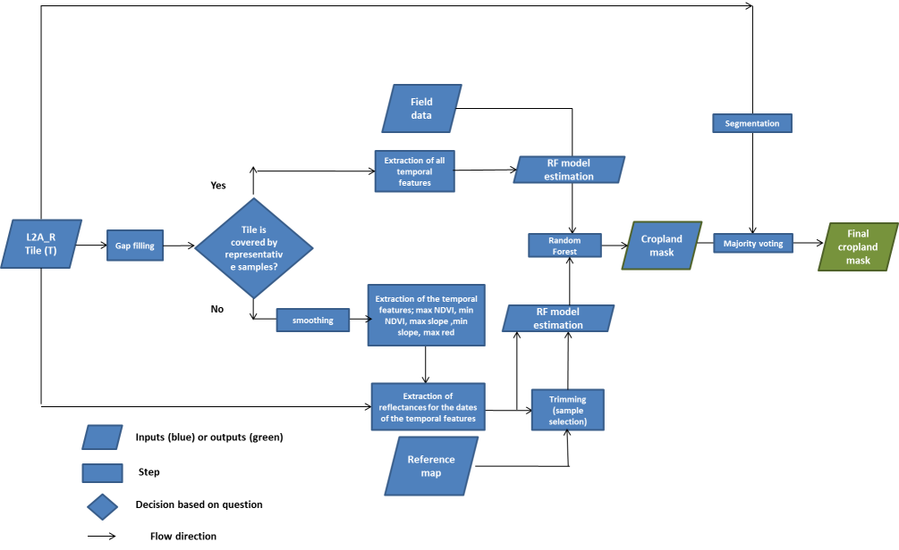

Figure 5‑1. Flowchart of the proposed system for the crop land product